National Data Opt-out

GP IT Change / GPSoC Requirements v2.0

Published 29 April 2019

Contents

Purpose of Document 3
Background 3
NDOP GP IT Change / GPSoC Requirements 5
Requirement Clarifications 6
Approach for delivering the National Data Opt-out 7
Validation Requirements – Upholding 8
Appendix A - Feasibility Stage Requirements Document 12
Appendix B - Requirements History/Change Log 12

Purpose of Document
This document details the background to the National Data Opt-out Programme (NDOP) and the required change, including the final set of requirements that have been developed through the GP IT Change and GP System of Choice (GPSoC) Requirements and Validation Engagement (RAVE) process via a series of workshops and Stakeholder consultations held between May 2017 and December 2018. Also outlined is the proposed timeframe for delivery of this change.

Background

The National Data Opt-out Programme aligns with the National Data Guardian (NDG) Review of Data Security, Consent and Opt-Out, published in July 2016, and with the National Information Board (NIB) framework “Personalised Health and Care 2020”, which was published in November 2014.
The NDG Review of Data Security, Consent and Opt-Outs was commissioned by the Secretary of State for Health and published on 6 July 2016. Following public consultation, the Government response ‘Your Data: Better Security, Better Choice, Better Care’ was published on the 12 July 2017. It endorsed the NDG recommendation to provide a new national opt-out to give people a clear choice about how their personal confidential data is used for purposes beyond their individual care.
The national data opt-out work takes place in the context of the drive to develop a digitised health and care system that offers patients more control and choice over the care they receive, improves their experience, provides them with better outcomes and delivers a more efficient health and care system.
Following the Government Response to the NDG review a national data opt-out has been developed for patients to opt out of sharing their confidential patient information for reasons other than their individual care and treatment. The national data opt-out went live on-line and in a non-digital version on 25 May 2018.
The national data opt-out will be introduced in a phased way, starting with the ability for patients to register their data opt-out preferences. The ability for the health and care system to be able to uphold opt-out preferences has started with NHS Digital and to be achieved incrementally by all health and care providers by March 2020.
The national data opt-out will not apply to people's individual care and treatment.
NHS Digital’s aim is to make sure health and care professionals have the information, tools and materials they need to help their patients make an informed decision about how their individual data will be used. As well as to also make sure that patients know how to access the national data opt-out and that it is transparent how their preferences are being applied across the health and care system.
The national data opt-out is part of a wider vision that aims to build patients' trust and confidence in how health and care services look after patient data and use it for the benefit of health and care, as well as assuring data security, across the health and care system.
The key points of the NDG review that fall within the scope of this development are:

- Patients in England should be able to securely set their opt-out preference(s) both on-line and in person on the basis of an agreed opt-out;

- When national data opt-out preferences are set, they will be applied across the whole English health and care system;

- All English health and care organisations must uphold national data opt-out preferences when sharing confidential patient information for purposes beyond their individual care.

In 2016 the National Data Opt-out Programme engaged with the Domain C GPSoC Advisory Board and were accepted to start the RAVE process, see the below diagram, with the aim to develop and deliver a national data opt-out solution for GP systems. Progress through the Foundation stage with the pre-project and feasibility stages of the process has been successfully completed. In October 2018 NDOP achieved priority status from GP IT Change / GPSoC in order to progress delivery aimed for completion in 2019.
The feasibility phase of the GPSoC RAVE process for the National Data Opt-out Programme identified a set of high level requirements, see Appendix A. During the Foundation stage these requirements have been reviewed and elaborated via a series of workshops and stakeholder consultations to develop this set of requirements, see pages 8-12, that are subject to GP system supplier consideration for the required changes to the GP Systems that will support GP practices and patients and their data sharing preferences. See Appendix B for a log of the requirements change history.
Please see Page 7 for detail regarding the approach and delivery timelines.

Requirements and Validation Engagement (RAVE) Process Overview
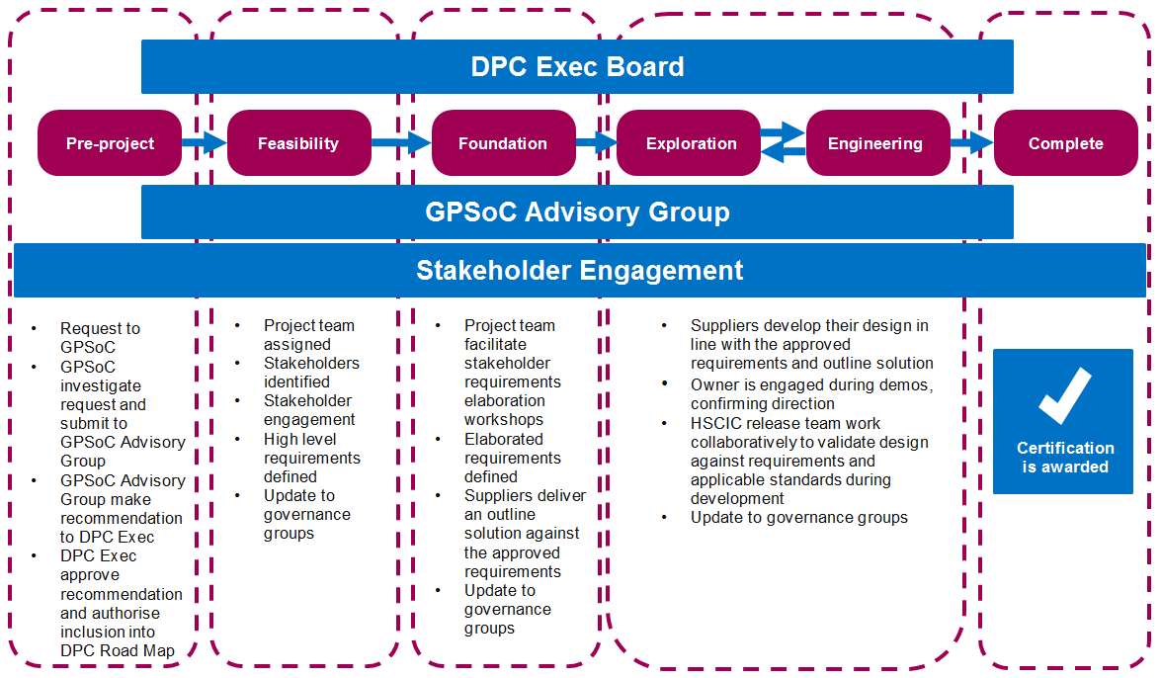

NDOP GP IT Change / GPSoC Requirements

The NDOP GP IT Change / GPSoC requirements concern:
- Upholding of National Data Opt-outs – GP Systems
The ability for a patient’s national data opt-out preference as recorded in the national repository to be upheld as required in data disseminations of confidential patient information for purposes beyond individual care from GP systems.

These requirements have been defined to date via meetings, workshops, consultations and subsequent feasibility studies undertaken within NHS Digital and with Stakeholders.

The NDOP requirements have been prioritised for delivery in line with MoSCoW principles, with requirements being identified as either:
MUST – Must have this requirement to meet the business needs
SHOULD – Should have this requirement if possible, but project success does not rely on it
COULD – Could have this requirement if it does not affect anything else on the project
WOULD – Would like to have this requirement later, but delivery won't be this time.
N/A – No longer required.

Requirements marked as ‘WOULD’ are not able to be delivered now for various reasons, including existing infrastructure, and will require additional elaboration and prioritisation before suppliers are expected to deliver them. Timeframes for this additional work are yet to be established. They are captured within these requirements to ensure the delivered service is improved over time and to ensure the work completed so far to elaborate these is not lost.

See pages 8-12 for the latest In-Scope NDOP ‘Upholding’ requirements.

It should be noted that the requirements defined within this document could be subject to further change and refinement.

Please note that RAVE NDOP requirement IDs may have changed from previous versions of this document.

Requirement Clarifications

Through stakeholder engagement and following the review of the outputs from the workshops it became evident that a number of clarifications around the scope for the change were required. These are presented below:

Clarification 1: Data Controllership
One of the exemptions to the national data opt-out set out in the NDG review is when there is a mandatory legal requirement – this includes the legal powers of NHS Digital to collect information when directed by the Secretary of State or NHS England under the Health and Social Care Act 2012. Therefore, the national data opt-out does not apply to flows into NHS Digital when it has been directed to collect the information. The review further clarified that the opt-out should not be applied to any already mandated data collections that pre-date the Health and Social Care Act 2012 e.g. Hospital Episode Statistics (HES) data.
When directed to collect data NHS Digital assumes data controller responsibilities for the national data set and is responsible for its use by NHS Digital including any onward release or sharing.
NHS Digital has published information about what it collects and how it processes these data, patient choices in the release of their data and information about procedures and safeguards governing the release of patient data. This includes checking that the flow is lawful, that data recipients have appropriate safeguards in place to store and handle the data safely and securely as well as independent challenge and scrutiny of the decisions made.
NHS Digital also publishes a data release register that sets out what data have been released, to whom and for what purpose. Data controllers providing data to NHS Digital would still need to provide clear information to patients that their data is shared with NHS Digital and that these are mandatory flows to which the national data opt-out does not apply.

Approach for delivering the National Data Opt-out

It is required that NDOP functionality for development of GP systems will be delivered to meet the National Data Opt-out implementation timelines, with solution(s) deployed and completion of this project to support GP practice readiness to meet their data controllership responsibilities and enable the upholding of National Data Opt-outs by September 2019.

The NDOP ‘Upholding’ requirements in the following tables on pages 8-12, provide the latest detail of the user stories and the requirements that are for consideration by GP system suppliers.

Supporting Information:

- National Data Opt-out Guidance & Policy:
https://digital.nhs.uk/services/national-data-opt-out-programme/guidance-for-health-and-care-staff

- MESH information – NDOP technical solution deployed by NHS Digital:
https://digital.nhs.uk/services/message-exchange-for-social-care-and-health-mesh

- Appendix A - High Level Feasibility Stage Requirements.

- Appendix B - Requirements History/Change Log.

In-Scope Validation Requirements

Upholding of national data opt-outs – GP Systems
ID | Description | Acceptance Criteria | Change History | Priority
RAVE-NDOP-014 | GP systems must provide information on how national data opt-out preferences were applied to any disclosures or data releases of confidential patient information made by the GP practice for purposes beyond individual care to support GP practice Data Controller responsibilities  – Note; this should relate to the data release as a whole rather than patient level releases  National Data Opt-out Information with a link to Operational Policy:  https://digital.nhs.uk/services/national-data-opt-out-programme/guidance-for-health-and-care-staff | Applies to all data from GP systems including any exports, extracts, releases, disseminations and disclosures from GP systems as defined by National Data Opt-out Operational Policy  GP Systems must capture the following data attributes;  - Date of data release  - Name of dataset (potential free text)  - Recipient of data (potential free text)  - Purpose of data release (free text)  - Application of the Upholding of National Data Opt-outs (Y or N indicator) (eg. if the opt-out has been upheld or not in the disclosure)  - This data must be available in an ad hoc report (data release register) or an equivalent  GP Systems must support user configuration of the following data attributes for ad hoc (data release register) or equivalent and for non-scheduled regional and national disclosures;  - Name of dataset (potential free text)  - Recipient of data (potential free text)  - Purpose of data release (potential free text)  GP Systems must provide users the ability to create an ad hoc report (data release register) or equivalent with the following data attributes;  - Date of data release  - Name of dataset (potential free text))  - Recipient of data (potential free text)  - Purpose of data release (potential free text)  - Application of the Upholding of National Data Opt-outs (Y or N indicator) (eg. if the opt-out has been upheld or not in the disclosure)  GP Systems must use the captured data attributes for an ad hoc report (data release register) or an equivalent | Workshop 1 -No change  Workshop 2 -Acceptance Criteria (A/C) added  31/8 Uplift – No change  02/01 March 2019 date included  21/03 Priority changed to Must and revision of requirement wording  30/04 Final A/C revised to reflect GP Systems must capture and report on data attributes and make it available under a data release register  Aug2018 - A/C updated to detail to apply to ‘all data’. Description updated to detail ‘GP practice Data Controller responsibilities’. Addition of NDOP weblink  Sept to Oct2018 – acceptance criteria and description updated for clarity  Nov to Dec 2018 – A/C revised for clarification, including potential formats for data attributes | Must
RAVE-NDOP-034 | Single or Multiple Patient disclosures / disseminations:  GP systems must be able to uphold the national data opt-out preferences when sharing confidential patient information for purposes beyond individual care in line with national policy  -Note; Patient identifiers are not removed prior to dissemination, rather the entire patient record is not disseminated  National Data Opt-out Information with a link to Operational Policy:  https://digital.nhs.uk/services/national-data-opt-out-programme/guidance-for-health-and-care-staff  Further detail on the technical solution deployed by NHS Digital - Message Exchange for Social Care and Health:  https://digital.nhs.uk/services/message-exchange-for-social-care-and-health-mesh  To note: For GP scenarios, there is acceptance in using the technical solution the GP system user/s will be informed of the patients opt-out status  To note: Historic patients is referred to as all patients that have ever been registered on a GP system regardless of status, for example, this includes any patients who have now transferred to another GP practice, marked as deceased or have been removed through a GP list cleansing activity etc. | National Data Opt-out applies to historic or previous patient data  NHS numbers for patients with Type 1 opt-outs must also be included when using the technical solution prior to any disclosures  All records for patients with a national data opt-out are removed from disclosures before the disclosure / dissemination process  National data opt-out preferences must apply to any disclosures of confidential patient information | 12/12 New requirement created out of RAVE-NDOP-013  30/04 Further two A/C added to explore whether some form of prompt or confirmation is possible. And making it explicit to what national data-opt out applies to  Aug2018 - Removal A/C, update of additional A/C entries. Description updated to define applying the upholding of opt outs. Addition of MESH weblink  Sept to Oct 2018 – Revision and addition to acceptance criteria for clarity and inclusion of Operational Policy weblink and effective from date  Nov to Dec 2018 – requirement revised to clarify criteria and the inclusion of all, new and historical patients. Supporting requirements RAVE-NDOP-034A and RAVE-NDOP-034B created to detail available option | Must
RAVE-NDOP-034A | To uphold the latest patient preferences, GP system suppliers should use the technical solution deployed by NHS Digital every time data is disclosed | GP systems should support a user in creating a list of valid only NHS numbers of all patients including historic for a disclosure / dissemination and utilise the technical solution to submit to NHS Digital for interrogation  The national data opt-out does not apply to non-valid NHS numbers  NHS Digital will return those NHS numbers for patients with no national data opt-out preference set  All records for patients not contained in NHS Digital returned records are removed from the disclosure | Nov to Dec 2018 - new supplementary requirements to support RAVE-NDOP-034. | Should
RAVE-NDOP-034B | GP systems could adopt National Data Opt-out cached data operational principles  To note: The cached data principles are aligned with the NHS Digital ‘Check for National Data Opt-outs Service Licence’ agreement:  https://digital.nhs.uk/services/national-data-opt-out-programme | The technical solution deployed by NHS Digital allows GP system suppliers on a scheduled basis to optionally cache the returned data for a time limited period  GP systems could support a user in creating a list of valid only NHS numbers of all patients including historic registration and utilise the technical solution to submit to NHS Digital for interrogation  NHS Digital will return those NHS numbers for patients with no national data opt-out preference set  All records for patients not contained in NHS Digital returned records are removed from all cohorts in the time limited period before any disclosure process  The following restrictions apply to the cached data:  - Access to the National Data Opt-out solution is provided for the purpose of enabling an organisation to comply with the national data opt-out policy only  - The cached data must be stored securely with appropriate access controls and only accessed for the purposes of applying opt-outs. This includes any cached and superseded cached data  - The cached data must not be used to identify patients with a national data opt-out  - The cached data must include all historic or previous patients  - The cached data must not be added to a patient record  - The cached data must not be shared with any other organisation unless it is for the express purpose of the other organisation being able to apply national data opt-outs on behalf of the GP Practice Data Controller  - The maximum time period that any cached data may be retained is a calendar week from the point at which it was obtained from the service. In the event of system failures that prevent the cached data being updated as expected, to ensure that the existing cached data does not continue to be used such that the national data opt-out fair processing window is exceeded  - The cached data must not be used to provide clinicians or other care staff with a view of a patient’s national data opt-out preference  - The superseded cached data must not be retained or disclosed in the ‘live’ system when the cached data is replaced at the prescribed interval of a calendar week. However, it is permissible to retain the superseded cached data in order to ensure that national data opt-outs have been applied as expected  - If it is necessary to restore data from a backup, the cached data must be replaced once the restore is complete if the cache is older than the prescribed limit of a calendar week  - The cached data may be disclosed where there is a legal or statutory reason for the disclosure (for example in response to a Subject Access Request from a patient)  - GP Systems must check the opt-out status for new patients on registration rather than waiting for the next scheduled cache refresh (to ensure that patient’s national data opt-out preference status is continued regardless of GP system variants and GP business transaction) | Nov to Dec 2018 – new supplementary requirements to support RAVE-NDOP-034. Following requirements elaboration with principal suppliers this requirement is to support suppliers to minimise the impact on their technical infrastructure.  April 2019 – acceptance criteria updated to further clarify aspects of the cached data principles.  To note: National Data Opt-out cached data is the cleansed file of NHS Numbers (national data opt-outs removed), that is returned and then stored for a time period to support the organisation in carrying out data disclosures. | Could
RAVE-NDOP-036 | GP systems must ensure patients National Data Opt-out preference status cannot be viewed within the GP system | The National Data Opt-out preference status applies to all patients | Nov to Dec 2018 – new requirement for clarification | Must
RAVE-NDOP-037 | All GP System variants (eg. community modules, Health and Justice modules, MOD modules) must be compliant with NDOP requirements | GP system variants under the GPSoC framework must align with principal GP systems and adhere to the acceptance criteria | Nov to Dec 2018 – new requirement for clarification | Must

Appendix A - Feasibility Stage Requirements Document

Appendix B – Requirements History/Change Log

