Document filename: SCR Viewing Requirements Refactored for the SCR FHIR API
Directorate / Programme | Live Services | Project | SCR
Document Location
Product Owner | Jill Sharples | Status | Approved
Owner | Robert Jordan | Version | 5.1
Author | Gina Jacobs | Version issue date | 21st September 2022

SCR Viewing Requirements Refactored for the SCR FHIR API

Document Management
Revision History
Version | Date | Summary of Changes
1.6 (Approved) | 22/02/2011 | Major release for CCN.099.
2.0 (Approved) | 20/12/2011 | See embedded Change History document below.
3.0 (Approved) | 24/04/2013 | See embedded Change History document below.  Approved for release.
4.0  (Draft) | 09/03/2015 | Final draft. Used in the creation of version 5.0 Refactored for the SCR FHIR API.
5.0  (Approved) | 05/05/2022 | Refactored for New Market Entrants using SCR FHIR API. See embedded Change History and Overview document below.
5.1  (Approved) | 20/09/2022 | Minor updates made to 4 requirements as a result of the E2E Risk Log review sessions and NME Hazard Log. See embedded Change History.

Reviewers
This document must be reviewed by the following people:
Reviewer name | Title / Responsibility | Date | Version
Robert Jordan | SCR Product Manager | 12/08/2022 | 5.1
Dr Robert Jeeves | SCR Clinical Lead and Clinical Safety Officer | 12/08/2022 | 5.1
Eric Lambley | Demographics Higher Business Analyst | 12/08/2022 | 5.1
Brian Diggle | Technical Architect API Management | 12/08/2022 | 5.1
Simon Lee | Assurance Lead – Solution Assurance | 12/08/2022 | 5.1
Simon Immanuel | Primary Care Technical Architect | 12/08/2022 | 5.1
David Barnet | Interoperability Lead | 12/08/2022 | 5.1
Shelley Johnston | SCR Service Manager | 12/08/2022 | 5.1

Approved by
This document must be approved by the following people:
Name | Signature | Title | Date | Version
Robert Marsh |  | Head of Live Services | 20/09/2022 | 5.1

Reference Documents
Ref | Document Location | Title | Version
1 | https://gpitbjss.atlassian.net/wiki/spaces/DCSDCS/pages/1391133699/Summary+Care+Record+SCR | GP IT Futures Information Governance Standard | 2.1.1
2 | https://digital.nhs.uk/services/registration-authorities-and-smartcards | RBAC Model | 27.2
3 | https://gpitbjss.atlassian.net/wiki/spaces/DCSDCS/pages/1391133699/Summary+Care+Record+SCR | SCR Permission to View Guidelines | 1.1
4 | https://gpitbjss.atlassian.net/wiki/spaces/DCSDCS/pages/1391133699/Summary+Care+Record+SCR | GP Summary Presentation Text Specification Refactored for SCR FHIR API | 4.0
5 | https://digital.nhs.uk/developer/api-catalogue/summary-care-record-fhir#api-Default-alert | AuditEvent endpoint specification
6 | https://gpitbjss.atlassian.net/wiki/spaces/DCSDCS/pages/1391133699/Summary+Care+Record+SCR | SCR API Error Responses document
7 | https://digital.nhs.uk/developer/api-catalogue/summary-care-record-fhir | SCR FHIR API Specification
8 | https://gpitbjss.atlassian.net/wiki/spaces/DCSDCS/pages/1391133699/Summary+Care+Record+SCR | SCR FHIR API Technical Specification for the GP Summary XHTML | 1.0

Glossary
Term | Abbreviation | Description
Care Episode | None | All care provided to a patient, for the duration of particular illness or condition.
Care Professional | None | An individual who provides care to a patient.
GP Summary Message | None | The electronic message containing the information associated with a patient’s Summary Care Record.
Legitimate Relationship | LR | A legitimate relationship (LR) is a connection between a patient and one or more Care Professionals that justifies access to the patient’s sensitive personal data (such as clinical information).
NHS Spine | None | A national store and set of services to securely store and manage patient related information for the NHS.
Permission to View | PTV | In order to view a Summary Care Record during a specific care episode, the patient must give his or her permission. This is recorded electronically and labelled Permission to View.
SCR Consent Preference | None | A value recorded on the NHS Spine that indicates if a patient opts out from having a SCR.
SCR Viewing System | None | A system that provides functionality to allow a care professional to access or view a selected patient’s SCR.
Spine Demographic Service | None | The NHS Spine service that stores and manages patient demographic information.
Summary Care Record | SCR | An electronic record held on the Spine, which contains key clinical information about the patient, sourced from the patient’s registered GP Practice
Demographic Batch Service | DBS | A NHS Demographic Spine service that allows NHS staff and systems to verify or find a patient’s NHS Number
Fast IDentity Online | FIDO | FIDO stands for Fast IDentity Online and FIDO2 is just an umbrella term for the combination of WebAuthn and CTAP.) The authenticator provides the cryptographic know-how in the whole transaction, generating and storing your keys, and encrypting the website's WebAuthn challenge on behalf of your browser.
User Role Profile | URP | A User Role Profile is the information about the clinical role an authenticated user is authorised to perform.
Universally Unique Identifier | UUID | A Universally Unique Identifier is a 128-bit number used to identify information in computer systems.
National Administrative Codes Service | NACS | The service previously known as the National Administrative Codes Service (NACS) is now known as the Organisation Data Service (ODS)
Organisation Data Service | ODS | The ODS is responsible for publishing organisation and practitioner codes, along with related national policies and standards. They’re also responsible for the ongoing maintenance of the organisation and person nodes of the Spine Directory Service, the central data repository used within various NHS systems and services.

Document Control:
The controlled copy of this document is maintained in the NHS England corporate network. Any copies of this document held outside of that area, in whatever format (e.g. paper, email attachment), are considered to have passed out of control and should be checked for currency and validity.

Contents
1. Introduction 6
1.1. Purpose of Document 6
1.2. Audience 6
1.3. Summary Care Record Background 6
1.4. SCR Care Settings 7
1.4.1. Requirements Types and Priorities 8
2. SCR Viewing System Requirements 9
2.1.1. Definitions 9
2.2. SCR Viewing Requirements 10
2.2.1. SCR Viewing Switch 10
2.2.2. Pre-conditions to accessing a patient’s SCR 10
2.2.3. Permission to View Process 14
2.2.4. Permission to View Requirements 17
2.2.4.1. Obtaining Permission to View 18
2.3. Creating Permission to View on behalf of Care Professionals 24
2.4. Alerting 25
2.4.1. Local Alerting 28
2.5. Rendering the Summary Care Record 30
2.6. Handling Error Situations 32
2.7. Storage of SCRs 33
2.8. Reporting 34
2.9. Auditing 36
2.10. Care Settings 36
3. Appendix 1 - Legitimate Relationship Requirements 36
4. Appendix 2 – Auditable Actions / Event 37
5. Appendix 3 - Summary of Information Governance Requirements 39
6. Appendix 4 - Example of Permission to View Process 40

Introduction

Purpose of Document
This document contains the business requirements that systems must adhere to, in order to provide integrated access to Summary Care Records (SCRs) for care professionals. In this context “integrated access”, can be defined as providing access to SCRs via the SCR FHIR API, without the use of third party software (such as a SCR Spine Mini Service) or web services (such as the Spine 1-Click Service), to obtain and render SCR content

Audience
Developers, analysts and architects developing a system that provides integrated SCR access.

Summary Care Record Background
A Summary Care Record is an electronic record of important patient information, created from GP medical records. They can be seen and used by authorised staff in other areas of the health and care system involved in the patient's direct care. Patients who are registered with a GP practice in England will have an SCR created automatically unless they have opted out. Each patient’s SCR consists of a GP Summary message held on the NHS Spine (Spine), which contains key clinical information about the patient, sourced from the patient’s registered GP Practice. GP Practices create and send a GP Summary message to the Spine (replacing any previous version), in response to various patient related events (such as change to the patient’s medication). A patient will only have a single accessible GP Summary (which will have a recorded document state of “Normal”) at any point in time and this version will be accessible to viewing systems and their users. Patients may choose not have a SCR at any time, which will both prevent the creation/update of the patient’s SCR and also make that patient’s SCR inaccessible to anyone (or system) that attempts to gain access.
SCRs are accessed in a variety of care settings by care professionals. The viewing of SCR is subject to a number of Information Governance (IG) controls and documented NHS England SCR Team requirements, to ensure that a SCR is only accessed by appropriate care professionals, in suitable circumstances. These IG controls can be summarised as follows:
- The viewer must have the appropriate Role Base Access Control (RBAC) in order to access the record. This in turn necessitates that the individual is NHS Smartcard (or equivalent) authenticated.

- The viewer must have a legitimate reason to access that patient’s SCR in the context of the particular episode of patient care (care episode). For example, the patient may be registered for care within an Emergency Department and the viewer may be one of the care professionals providing care to the patient.

- The patient must not have dissented to have Summary Care Record. This is termed the patient’s SCR Consent Preference and is recorded both centrally on Spine and also locally within the patient’s registered GP Practice.

- The patient must have provided “Permission to View” their SCR, for the duration of the care episode, to appropriate individuals involved in their care. In exceptional circumstances, a care professional may choose to access a patient’s SCR without the patient’s permission. For example, access may be necessary for emergency or for legal reasons . Permission to View will be managed by the SCR Viewing System.

- Electronic Alerts are generated and subsequently investigated by NHS Privacy Officers, when:

  - A SCR is accessed without the patient’s permission

and/or

  - The equivalent of Self-Claim Legitimate Relationship is created by an individual, who subsequently accesses the patient’s SCR.
The IG controls associated with accessing a SCR must be provided by a combination of the SCR Viewing System, the SCR FHIR API and Spine Services.

SCR Care Settings
The original scope of the Summary Care Record (SCR) was to provide access to key information in Urgent and Emergency Care settings. Over time, through close consultation with the Expert Advisory Committee and further consultation with patients and health and care professionals through their extended networks, NHS England have progressed a number of Proof of Concepts to see whether there are benefits, both for patients and health and care professionals, for other care settings to access the SCR. The current list of care settings approved for national rollout to view SCR, where a legitimate relationship exists, is published on the NHS England website.
Analysis of access to SCRs in various urgent and unscheduled care settings has identified common features and also common business / system processes. As patient encounters and access to the SCR in these care settings is unplanned:
- The patient’s demographics will be unknown prior to the patient encounter and will need to be identified and verified.

- It will not be known if the patient has a SCR available to access (i.e. has a GP Summary in a suitable state been “uploaded” to the NHS Spine).

- It will be unclear if the patient has dissented to have SCR via the SCR Consent Preference.

- It is unlikely that there is the equivalent of a pre-existing Legitimate Relationship between the patient and the care professional(s) and this will need to be created.

- It is unlikely that Permission to View exists between the patient and the care professional(s) and will need to be created and managed.

- The patient may be incapable of giving consent to access their SCR for some reason. For example, the patient may be unconscious or incapacitated in some way.

- The need to access the SCR is immediate and urgent.

- It is likely that there will be a single point of admission for patients. For example, a reception desk.
Many of the principles above apply to care provided in other care settings beyond urgent and emergency care.

Requirements Types and Priorities
Each requirement has a priority, which is stated using the keywords MUST, MAY, and SHOULD:
- MUST - This word, or the terms "REQUIRED" or "SHALL", means that the definition is an absolute requirement of the specification.

- SHOULD - This word, or the adjective "RECOMMENDED", means that there may exist valid reasons in particular circumstances to ignore a particular item, but the full implications must be understood and carefully weighed before choosing a different course.

- MAY - This word, or the adjective “OPTIONAL”, means that an item is truly optional. One implementer may choose to include the item because a particular implementation requires it or because the implementer feels that it enhances the implementation while another implementer may omit the same item. An implementation which does not include a particular option MUST be prepared to interoperate with another implementation which does include the option, though perhaps with reduced functionality. In the same vein, an implementation which does include a particular option MUST be prepared to interoperate with another implementation which does not include the option (except, of course, for the feature the option provides).

SCR Viewing System Requirements

Definitions
For the purpose of these requirements the following terms MUST be interpreted as follows:
Term | Meaning
Alert | An Electronic Alert raised to an organisation’s Privacy Officer(s), when a Care Professional in the same organisation creates a Self-Claim LR or accesses an SCR without the patient’s permission.
Administrative Support User | An individual who has the local permissions to create “Permission to View” on behalf of one or more Care Professionals, but does not have the RBAC activities (in his or her current role) to access a SCR.
Care Professional | Refers to an individual, in a specific Smartcard Role, who potentially may access a patient’s Summary Care Record.
Demographic Batch Service (DBS) | A NHS Demographic Spine service that allows NHS staff and systems to verify or find a patient’s NHS Number
Document Effective Time | The date and time that a GP System created a GP Summary message. This information is stored within the GP Summary message.
GP Summary | The electronic message containing the information associated with a patient’s Summary Care Record. This term encompasses both Initial GP Summary and GP Summary messages.
GP Summary Presentation Text | A NHS England SCR Team requirements document that defines the structure of the text section within the GP Summary Message.
Legitimate Relationship (LR) | A legitimate relationship (LR) is a connection between a patient and one or more Care Professionals that justifies access to the patient’s sensitive personal data (such as clinical information).
Local Alerting Solution | Functionality and information provided by a SCR Viewing System (not by Spine messaging and service) that provides Privacy Officers with the ability to identify and manage SCR related Alerts.
Permission to View Process | The various steps and processes associated with a Care Professional either, gaining the patient’s explicit permission to access their SCR or a Care Professional accessing a SCR for emergency or legal reasons.
Render a SCR | This will refer to the display of a SCR in any format, electronic or paper.
Role | This must be interpreted as being equivalent to a User’s current Spine authenticated User Role Profile (URP).
SCR Viewing functionality | All SCR Viewing System functionality associated with providing a Care Professional with access to SCRs.
SCR Viewing System | A system that provides functionality to allow a care professional to access or view a selected patient’s SCR.
Self Claim Legitimate Relationship | A type of Legitimate Relationship, whereby a Care Professional who accesses a patient’s record, claims the existence of a Legitimate Relationship without the involvement of any third party.
Self-Referral LR | A type of Legitimate Relationship whereby the Care Professional who accesses a patient’s record and hence claims the existence of a Legitimate Relationship, is not the same individual that recorded the patient's details (see CPR.047) or retrieved the patient's details at the beginning of the episode of care. There is role separation
User | A generic term to refer an individual who may either be Care Professional or an Administrative Support User
User Session | The time period between a user “logging onto” a client system and then explicitly logging out of the system or being automatically logged out by the system after a system defined time of user inactivity.

SCR Viewing Requirements

SCR Viewing Switch
CPR.077 SCR Viewing Switch
The SCR Viewing System MUST implement, a per-organisation software configuration SCR Viewing Switch that will control whether specific organisations can or cannot provide access to SCRs.
- "Per-organisation" MUST be sufficiently low-level to allow switching “ON” or “OFF” of SCR Viewing functionality at individual GP practices, hospitals, clinics, etc.

- The system MUST only allow the SCR Viewing Switch to be set to "ON" or "OFF" by system administrators with appropriate permissions.

- When the SCR Viewing functionality is made available to an organisation, the switch MUST be set by default to "ON".

- When a system administrator attempts to set the switch to "OFF", the system MUST display a warning to the system administrator that this will switch “OFF” SCR Viewing functionality for patients who are not fully GMS (General Medical Services) registered at the organisation.

- When a system administrator attempts to set the switch to "ON", the system MUST display a warning to the system administrator that this will switch “ON” SCR Viewing functionality for patients who are not fully GMS (General Medical Services) registered at the organisation.

- For systems which send GP summaries, the SCR viewing switch MUST be independent of the GP Summary sending switch.

Note: Systems that send GP Summaries (SCRs) to the Spine have a “GP Summary sending switch” that controls whether the sending of GP Summaries is or is not enabled within the organisation (GP Practice).

Pre-conditions to accessing a patient’s SCR
The requirements in this section specify pre-conditions prior to a Care Professional accessing a patient’s SCR. The SCR Viewing System must ensure that:
- The patient details must be recorded on the SCR Viewing System

- The patient’s identity must be verified against the Spine Demographic Service.

- The Care Professional must be Spine Smartcard (or equivalent) authenticated.

- The Care Professional must have the appropriate RBAC permissions to access the patient’s SCR. Multiple RBAC Activities control access to a patient’s SCR. Separate RBAC Activities are required to:

  - Access a patient’s SCR with the patient’s permission
  - Access the SCR for emergency reasons
  - Access the SCR for legal reasons.

- A Legitimate Relationship, or the equivalent of, must exist between the Care Professional and the patient

CPR.047: Record patient details before viewing their SCR
The SCR Viewing System MUST provide functionality to access a patient's SCR, but only for patients whose details are recorded on the system. As a minimum, the following details SHOULD be recorded on the system: NHS Number, Surname, Gender, Date of Birth, and either Forename or Postcode.

CPR.060:The patient’s identity MUST be verified against the Spine Demographic Service
- Before allowing a Care Professional to access a patient’s SCR, the SCR Viewing System MUST verify the patient's identity by verifying the patient's demographic details held on the SCR Viewing System, with the patient's demographic details held on the Spine Demographic Service.

- The selected patient’s NHS Number MUST be traced and \ or verified in one of the following ways:

- Using the Demographic Batch Service (DBS).
OR
- In a non-interactive (system-driven) function, as part of an SCR Viewing System using the algorithms in A.
OR
- The patient’s Spine Demographic Service record must be confirmed (by a User) through an interactive tracing process using an SCR Viewing System using the Algorithms in A.
A: Demographic Verification Algorithm in a Non-Interactive Scenarios
One of the following algorithms MUST be used:
- If no NHS Number exists locally, an exact match on Spine Demographic Service of Surname, Forename, Gender, Date of Birth, and Postcode may be considered a verified match.
OR
- If an NHS Number exists locally then it can be considered verified if the NHS Number and Date of Birth (YYYYMMDD) match a Spine Demographic Service record.
OR
- If an NHS Number exists locally then it can be considered verified, if the NHS Number, 2 out of 3 of the elements of Date Birth (a single element being YYYY, MM or DD), the first 3 characters of Surname, first character of Forename all match the Spine Demographic Service record.

CPR.014: The Care Professional MUST be Smartcard (or equivalent) Authenticated
Before allowing a Care Professional to access a selected patient’s SCR, the SCR Viewing System MUST ensure that the Care Professional is authenticated using one of 4 categories of authentication method which is according to the national RA policy:
- Physical Smartcard which is supplied by the authorised supplier(s) of cards to NHS England and are similar to chip and PIN bank cards.

- Virtual Smartcard which is a solution that provides access functionality, but the card itself may be stored on a device, approved for use by NHS England and / or its partners.

- Authorised Device which is an alternative to smartcards. The device must be approved by FIDO 2 Consortium that provides Assured Level 3 Authentication.

- iPad device which must authenticate using the NHS England created authentication app which follows the FIDO patterns of cryptographic exchange.
AND
- Has selected a Spine User Role Profile (URP) that allows access to the selected patient’s SCR. Refer to CPR.016.

CPR.016: The Care Professional MUST have the RBAC Permissions to access the patient’s SCR
- The SCR Viewing System MUST ensure that only individuals with the appropriate RBAC activities on their current Smartcard (or equivalent) Role (URP) can access a patient’s SCR. Refer to [Ref.2] for guidance on implementing RBAC for SCR Viewing and use of Demographic Spine Services.

- The SCR Viewing System MUST ensure that a Care Professional is only offered the options to access a SCR, that match the RBAC activities associated with the Care Professional’s current Smartcard (or equivalent) Role (URP). For example, if the Care Professional did not have the RBAC to access SCRs for emergency reasons, that option must not be offered to the Care Professional by the SCR Viewing System.

- The SCR Viewing System must ensure that RBAC Activities associated with the provision of SCR Viewing functionality are configurable at system level to take into account possible future changes in the RBAC activity codes.
Note: Discrete RBAC activities are required to access the patient SCR, with the patient’s permission, for emergency reasons and for legal reasons. For example, a Care Professional may only have the RBAC activities to access a patient’s SCR with the patient’s permission, but in another role the same Care Professional may be able to access the SCR with the patient’s permission and for emergency reasons but not for legal reasons. In addition, a local Viewing System may use RBAC to manage the creation of Self-Claim LRs.

CPR.062: A legitimate relationship, or the equivalent of, MUST exist between the Care Professional and the patient
Overview
The SCR Viewing System MUST ensure that a Care Professional can only access a patient’s SCR if in the context of the current care episode, the Care Professional has a legitimate reason to access the patient’s SCR. Legitimate Relationships are distinct from the existence of Permission to View.
The equivalent of a legitimate relationship (LR) MUST exist between the Care Professional and the selected patient, before the SCR Viewing System can allow access to the patient’s SCR.
In most cases, a user viewing a patient's SCR will not be the same user that recorded the patient's details (see CPR.047) or retrieved the patient's details at the beginning of the episode of care, i.e. there is role separation. This is a self-referral LR.
In cases where the same user records the patient's details on the system or retrieves the patient's pre-existing details, and then views their SCR, there is no role separation. This is a Self-Claim LR and an Alert must be raised when created. A Self-Claim LR has duration of 5 days and once expired, a new LR must be created in order to access a patient’s SCR.
Requirement
In order to ensure that sufficient controls are in place:
- The SCR Viewing System MUST ensure that a legitimate relationship, or the equivalent, exists between the Care Professional and the patient, prior to allowing a Care Professional to access the SCR.

- The SCR Viewing System MUST support LRs through existing system behaviour.

- The SCR Viewing System must be assured against the relevant sections of the Information Governance Baseline associated with legitimate relationships, to ensure that SCR access is only allowed when a Care Professional has a legitimate reason. Appendix 1 contains an extract of the relevant Information Governance Baseline requirements.

CPR.165: Creation of Self-Claim Legitimate relationship
- The SCR Viewing System MUST automatically create a Self-Claim LR (using existing system functionality) in order to allow access to selected patient’s SCR if:

  - A current LR does not exist between the selected patient and the specific Care Professional in his / her current Smartcard (or equivalent) Role (URP)

AND

  - The Care Professional who registered the selected patient for the care episode accesses the patient’s selected patient’s SCR

- The SCR Viewing System MUST raise a Self-Claim LR Alert when a new Self-Claim LR is created, regardless of whether a LR previously existed between patient and the Care Professional. Refer to MSCA-SCR-100, MSCA-SCR-101 and MSCA-SCR-103 for the details of the requirements associated with raising and populating a Self-Claim Alert.

- The creation of the Self-Claim LR SHOULD take place in the background at the same time the Care Professional accesses the selected patient’s SCR.

- The SCR Viewing System MUST ensure that only Care Professionals with appropriate local system permissions or appropriate national RBAC activities, can create Self-Claim LRs. This nature of any non-RBAC controls to create Self-Claim LRs MUST be agreed with the NHS England SCR Team. Refer to [Ref.2] for guidance on the RBAC activities required to create a Self-Claim LR.

Permission to View Process
This section is concerned with the requirements and processes associated with obtaining the patient’s Permission to View (PTV) their SCR and also accessing the SCR for emergency or legal reasons. Permission to View has the following features:

- It starts and ends at specific point in time, with a duration appropriate to the circumstances of the SCR access. The SCR Viewing System must ensure that the duration of PTV is appropriate. Once expired, the Care Professional must again obtain the patient’s ‘Permission to View’ in order to access the patient’s SCR.

- It is associated with a specific patient and one or more Care Professionals who potentially may need to access a patient’s SCR during a specific care episode. For example, a hospital pharmacist may require access to a patient’s SCR during the patient’s stay in hospital, in order to dispense medication.

- A patient should be asked prior to any SCR access, whether he / she agrees to one or more Care Professionals accessing his / "her SCR. Example questions include, "Is it okay if myself and my colleagues can view your SCR for the duration of your stay in this hospital?", or "Is it okay if I can view your SCR until the end of today”? The patient’s response will govern which Care Professional(s) can be granted Permission to View and the SCR Viewing System must ensure it only creates Permission to View for those Care Professionals.

- There is no RBAC control associated with the creation and management of Permission to View, as opposed to actually viewing or accessing the SCR (which is RBAC controlled). Instead the SCR Viewing System must ensure that only users with appropriate local permissions can create Permission to View either for themselves or on behalf of others.

- Permission to View may be created via SCR Viewing Systems either by:

- The Care Professional who will subsequently access the patient’s SCR.

OR

- An Administrative Support User, who creates Permission to View on behalf of one or more Care Professionals.

Process to obtain Permission to View for a Care Professional
The SCR Viewing System must enforce a specific ‘Permission to View Process’ via its user interface to help ensure that a patient’s SCR is only accessed in appropriate circumstances. This process is summarised below:
- If the patient does not have an accessible SCR, the SCR Viewing System MUST clearly indicate this to any Care Professional who attempts to access the SCR. For example, a patient will not have an accessible SCR if a GP Summary Message associated with that patient has not yet been uploaded to the Spine.

- If the patient does have an accessible SCR AND “Permission to View” is currently recorded between the patient and the Care Professional, the SCR Viewing System MUST allow the Care Professional to access the patient’s SCR on request, providing all other pre-conditions for SCR access have been fulfilled.

- If the patient does have an accessible SCR AND “Permission to View” is NOT currently recorded between the patient and the Care Professional, the SCR Viewing System MUST (subject to RBAC permissions) provide the Care Professional with the following options for access appropriate to the current care episode:

- Access the patient’s SCR with permission, for that Care Professional only
- Access the patient’s SCR with permission for the Care Professional and other colleagues who may require access during the current care episode
- Emergency Access to the SCROption to indicate that the patient has refused access.

Depending on the system and clinical context, a SCR Viewing System may also offer a Care Professional the option to access the patient’s SCR for legal reasons (subject to the individual having the appropriate RBAC permissions in their current role).

- A SCR Viewing System may also offer functionality to allow an Administrative Support User, to obtain and record a patient’s “Permission to View” on behalf of one or more Care Professionals who may be involved in the patient’s current care episode.

Example screenshots of a system that has implemented the ‘Permission to View’ Process are provided in Appendix 5.

Emergency Access
If access to a patient’s SCR is for emergency reasons:
- The SCR Viewing System must ensure that the Care Professional provides a reason for the emergency access, prior to allowing access to the SCR.

- The SCR Viewing System must raise a Spine Access Alert to notify Privacy Officer(s) in the organisation associated with the Care Professional’s current role (URP), of the ‘emergency’ SCR access. The content of the Alert must include the reason for the emergency access, provided by the Care Professional.

- Emergency access can only be initiated by a Care Professional accessing the SCR and cannot be created by a non-clinical Administrative Support User.

- Permission to View must not be created. The SCR Viewing System must only allow access to the patient’s SCR either for the duration of the current view or, at most, the duration of the current user session only.

Legal Access
If access to a patient’s SCR is for legal reasons:
- Prior to allowing access to the SCR, the SCR Viewing System must ensure that the Care Professional provides a free text justification for the access and also selects one of the following reasons:

  - Access made in the public interest
  - Access required by statute
  - Access required by court order.

- The SCR Viewing System must raise a Spine Access Alert to notify Privacy Officer(s) in the organisation associated with the Care Professional’s current role (URP), of the “legal” SCR access. The content of the alert must include the reason and free text justification for the legal access, provided by the Care Professional.

- Legal access can only be initiated by a Care Professional accessing the SCR and cannot be created by a non-clinical Administrative Support User.

- Permission to View must not be created. The SCR Viewing System must only allow access to the patient’s SCR either for the duration of the current view or, at most, the duration of the current user session only.

Permission to View Requirements
CPR.064 SCR Permission to View Guidelines
Any organisation that provides access to the SCR via a SCR Viewing System MUST adhere to the principles stated in the document “Permission to View Guidelines” [Ref. 3].

CPR.041 Obtaining a Patient's SCR Consent Preference
- The system MUST always check a patient's Spine recorded SCR Consent Preference (using the GET /DocumentReference API call, which returns "Yes/No/Ask" in the securitylabel) before viewing a patient's SCR.

- If the patient’s SCR Consent Preference is the equivalent of:
"The patient does not have a Summary Care Record (has opted out)" indicated by a response of “No”, the SCR Viewing System MUST ensure that the patient’s SCR is not accessible to any Care Professional or any other system user.
- If the patient's SCR Consent Preference cannot be determined e.g. due to a network error, local system error, Spine offline, etc), then the SCR Viewing System SHOULD still attempt to view the patient's SCR and handle any errors. The system MUST assume that the patient needs to be asked for Permission to View their SCR.

MSCA-SCR-06: The SCR Viewing System MUST identify if the patient has an accessible SCR
Prior to allowing a Care Professional to attempt to access a SCR, the SCR Viewing System MUST check if a patient has an accessible SCR. A patient MUST be considered to have an accessible SCR if:
- The patient has a Spine stored GP Summary that has a Document State of Normal.

- The patient is not recorded on Spine as opting out /dissenting to have a SCR. Refer to CPR.041.

MSCA-SCR-07: Users SHOULD be informed if a SCR is accessible.
The SCR Viewing System SHOULD clearly indicate to a Care Professional or Administrative Support User whether a selected patient has an accessible SCR, before the Care Professional makes any attempt to:
- Access that patient’s SCR .

- Obtain the patient’s Permission to View their SCR.
Refer to MSCA-SCR-06 for the definition of an accessible SCR.

MSCA-SCR-08: Pre-conditions to initiating the ‘Permission to View Process’
Prior to allowing a Care Professional to initiate the “Permission to View” process, the SCR Viewing System MUST:
- Identify if the selected patient has an accessible SCR. Refer to MSCA-SCR-06 for the definition of an accessible SCR.

- Identify if Permission to View currently exists between the specified patient and Care Professional’s current Smartcard (or equivalent) Role (URP). The SCR Viewing System MUST implement and manage “Permission to View” within the system.

- Ensure that the Care Professional has the appropriate RBAC activities to access the patient’s SCR. Refer to CPR.016.

MSCA-SCR-09: The Care Professional MUST be informed if the patient does not have an accessible Summary Care Record
If a Care Professional attempts to access a specific patient’s SCR AND it is identified that the patient DOES NOT have an accessible SCR, the SCR Viewing System MUST:
- NOT allow access to the selected patient’s SCR
AND
- Indicate clearly to the Care Professional that the patient’s SCR is not available for access and the reason(s) why the SCR is not available for access.
Refer to MSCA-SCR-06 for the definition of an accessible SCR.

MSCA-SCR-10: The Care Professional MUST be able to access the patient’s SCR in the circumstance where Permission to View currently exists
The SCR Viewing System MUST allow the Care Professional to access a patient’s SCR on request if:
- It is identified that the patient DOES have an accessible SCR. Refer to MSCA-SCR-06 for the definition of an accessible SCR.
AND
- Permission to View is currently recorded as existing between the patient and Care Professional’s current Smartcard (or equivalent) Role (URP).
AND
- All other pre-conditions for accessing a patient’s SCR have been fulfilled. Refer to CPR.047, CPR.060, CPR.014, CPR.016, and CPR.062 for the details of the pre-conditions.

If a current LR does not exist and all other pre-conditions for accessing a patient’s SCR have been fulfilled (CPR.047, CPR.060, CPR.014 and CPR.016) and the Care Professional has the appropriate permission to create a LR:
- The SCR Viewing System MUST create a Self-Claim LR and associated alert. Refer to CPR.165 for the requirements associated with creating a Self-Claim LR.
- Allow access to the patient’s SCR.

Obtaining Permission to View
MSCA-SCR-11: Obtaining Permission to View
The SCR Viewing System MUST implement the following process via its user interface to obtain ”Permission to View” or record access to the SCR for emergency reasons if:
- A Care Professional chooses to access the SCR of a patient who has an accessible SCR. Refer to MSCA-SCR-06 for the definition of an accessible SCR.

AND

- Permission to View is not recorded on the system as existing between the patient and Care Professional.
The process is as follows:
- The SCR Viewing System MUST display to the user "Has this patient given permission to view their Summary Care Record?" and "The usual legal, ethical and professional obligations apply when accessing a patient's clinical record".

- The SCR Viewing System MUST make available to the user, any options which are appropriate to the current care episode AND MUST NOT make available any of the options for which the user does not have the correct RBAC activities in their current Smartcard (or equivalent) Role.

- The SCR Viewing System MUST ensure that only Care Professionals with appropriate local permissions, can create Permission to View on behalf of other Care Professionals (within their current team) (Option 1b below):

1. Yes (View Record)
Obtain permission for:
1a. Yourself only
1b. Your workgroup or team
2. No (Access Refused)
3. Emergency Access
4. Access for Legal Reasons

The SCR Viewing System MAY implement different wording for any of the options above, providing it has been agreed with the NHS England SCR Team.
Further details of the functionality associated with each option is specified as follows:
Refer to MSCA-SCR-12 for the behaviour associated with options 1 and 1a
Refer to MSCA-SCR-13 for option 1b.
Refer to MSCA-SCR-16 for option 2.
Refer to MSCA-SCR-14 and MSCA-SCR-15 for option 3
Refer to MSCA-SCR-50 and MSCA-SCR-51 for option 4
There are no restrictions on how many times a user can go through this “Permission to View” process for a given patient, regardless of previous outcomes.

MSCA-SCR-12: Creating Permission to View for the current Care Professional Only (Permission to View Option 1 and 1a )
If a Care Professional chooses to access the patient’s SCR for him / herself only (Permission to View Options 1 and 1a).
AND
Permission to View is not currently recorded on the SCR Viewing System, as existing between the selected patient and the Care Professional:

- The SCR Viewing System MUST create Permission to View between the Care Professional in their current Smartcard Role and the selected patient for a specific duration. Refer to MSCA-SCR-17 for the requirements associated with specifying the duration of Permission to View.

- If a current LR does not exist and if the Care Professional has the appropriate permissions, the SCR Viewing System MUST create a Self-Claim LR and associated Self Claim Alert. Refer to CPR.165 for the requirements associated with creating a Self-Claim LR.

- The SCR Viewing System MUST immediately make the selected patient’s SCR available to the Care Professional to access, providing all other pre-conditions for accessing the selected patient’s SCR have been fulfilled. Refer to CPR.047, CPR.060, CPR.014, CPR.016, and CPR.062 for the details of the pre-conditions.

MSCA-SCR-13: Creating Permission to View for multiple Care Professionals (Permission to View Option 1b )
If a Care Professional chooses to create Permission to View for him / herself AND other Care Professionals who may be involved in the patient’s current care episode (Permission to View Option 1b)
AND
If Permission to View is not currently recorded as existing between a patient and a Care Professional (who has the RBAC to access a SCR in their current Smartcard (or equivalent) Role):

- The SCR Viewing System must create Permission to View between appropriate Care Professionals involved in the patient’s current care episode and the selected patient for a specific duration. Refer to:
  - MSCA-SCR-17 for the requirements associated with specifying the duration of Permission to View.
  - MSCA-SCR-35 for the requirements associated with identifying which Care Professionals should be granted Permission to View in the context of a specific care episode.

- If a current LR does not exist and if the Care Professional has the appropriate permissions, the SCR Viewing System MUST create a Self-Claim LR and associated Self Claim Alert. Refer to CPR.165 for the requirements associated with creating a Self-Claim LR.

- The SCR Viewing System MUST immediately make the selected patient’s SCR available to the Care Professional to access, providing all other pre-conditions for accessing the selected patient’s SCR have been fulfilled. Refer to CPR.047, CPR.060, CPR.014, CPR.016, and CPR.062 for the details of the pre-conditions.

MSCA-SCR-14: Confirmation of Emergency Access
If a Care Professional chooses to access the SCR for emergency reasons (Option 3. Emergency Access), the SCR Viewing System MUST:
- Display the following to the Care Professional:

"You may access this patient's record in the best interests of the patient if they are not able to give permission themselves, e.g. the patient is unconscious or confused. This action will be audited by the system and an alert will be sent to your privacy officer for monitoring purposes. Any breaches of patient confidentiality will be investigated and may be a matter for disciplinary proceedings. If in doubt, speak to your manager or privacy officer".

- Ensure that the Care Professional provides a reason for the emergency access. The Care Professional MAY enter the reason for the access in free text or the SCR Viewing System may allow the Care Professional to choose from a list of appropriate values. For example, “The patient is unconscious and requires care.”

- The system MUST allow the user either to continue and access the patient's SCR, or cancel and return to the screen they came from prior to choosing to view the patient's SCR. Refer to MSCA-SCR-15 for the requirement associated with accessing a SCR for emergency reasons.

MSCA-SCR-15: Accessing the SCR for Emergency Reasons
If a Care Professional confirms that they wish to access the SCR for emergency reasons (as defined in MSCA-SCR-14) the SCR Viewing System MUST:
- Raise an Access Alert indicating that the Care Professional has accessed the selected patient’s SCR in an emergency. The SCR Viewing System MUST ensure that the reason for the “emergency access” specified by the Care Professional (referred to in MSCA-SCR-14), is included within the alert. Refer to MSCA-SCR-100, MSCA-SCR-102 and MSCA-SCR-104 for the requirements associated with creating and populating the alert.

- If a current LR does not exist and if the Care Professional has the appropriate permissions, the SCR Viewing System MUST create a Self-Claim LR and associated Self Claim Alert. Refer to CPR.165 for the requirements associated with creating a Self-Claim LR.

- Immediately make the selected patient’s SCR available to the Care Professional to access, providing all other pre-conditions for accessing the selected patient’s SCR have been fulfilled. Refer to CPR.047, CPR.060, CPR.014, CPR.016, and CPR.062 for the details of the pre-conditions.

MSCA-SCR-50: Confirmation of Legal Access
If a Care Professional chooses to access the SCR for legal reasons (Option 4. Legal Access), the SCR Viewing System MUST:
- Display the following to the Care Professional:

"In exceptional circumstances you may be justified in accessing this patient's record without their permission" and "Any inappropriate breach of patient confidentiality will be a matter for disciplinary and potentially legal and/or professional proceedings. If in doubt speak to your manager or privacy officer".

- Ensure that the Care Professional selects one of the following three reasons for accessing the patient's SCR without the patient's permission:
  - Access made in the public interest
  - Access required by statute
  - Access required by court order

- Ensure that the Care Professional provides a free text reason for the legal access.

- Allow the user to either to continue and access the patient's SCR, or cancel and return to the screen they came from prior to choosing to view the patient's SCR.

MSCA-SCR-51: Accessing the SCR for Legal Reasons
If a Care Professional confirms that they wish to access the SCR for legal reasons (as defined in MSCA-SCR-50) the SCR Viewing System MUST:
- Raise an Access Alert indicating that the Care Professional has accessed the selected patient’s SCR for legal reasons. Refer to MSCA-SCR-100, MSCA-SCR-102 and MSCA-SCR-105 for the requirements associated with creating and populating the alert.

- The SCR Viewing System MUST ensure that the reason and the free text explanation for the legal access specified by the Care Professional (referred to in MSCA-SCR-50), are included within the Spine Alert. Refer to MSCA-SCR-105 for details of raising an alert.

- If a current LR does not exist and if the Care Professional has the appropriate permissions, the SCR Viewing System MUST create a Self-Claim LR and associated Self Claim Alert. Refer to CPR.165 for the requirements associated with creating a Self-Claim LR.

- Immediately make the selected patient’s SCR available to the Care Professional to access, providing all other pre-conditions for accessing the selected patient’s SCR have been fulfilled. Refer to CPR.047, CPR.060, CPR.014, CPR.016, and CPR.062 for the details of the pre-conditions.

MSCA-SCR-16: Patient refuses Permission to View
If the Care Professional selects the option indicating that the patient has refused “Permission to View” (Option 2. No (Access Refused)), the SCR Viewing System MUST NOT allow the Care Professional to access the patient’s SCR until Permission to View has been obtained.

MSCA-SCR-17: Duration of Permission to View
The SCR Viewing System MUST fulfil the following requirements when specifying the duration of Permission to View for either a specific Care Professional or group of Care Professionals:
“Permission to View” obtained from the patient (Options 1, 1a and 1b)
If the outcome of the Permission to View Process (specified in MSCA-SCR-11 or MSCA-SCR-19) is that the user selects an option indicating that the patient has provided “Permission to View” (Options 1,1a and 1b)
AND
Permission to View is NOT currently recorded between the selected patient and Care Professional(s):
- The SCR Viewing System MUST ensure that the duration of the Permission to View is one of the following:
  - For the remainder of the current care episode. The Care Professional accessing the SCR may provide details of the duration of the care episode.
  - For a fixed duration (such as 24 hours, a week, etc.) agreed with the NHS England SCR Team.
  - Some other duration, in agreement with the NHS England SCR Team.

Emergency Access and Legal Access
If the outcome of the Permission to View Process (specified in MSCA-SCR-11) is that the Care Professional selects an option indicating that the SCR access is for emergency reasons (Option 3) or legal reasons (option 4), then the SCR Viewing System MUST ensure that the Care Professional can access the patient’s SCR for one of the following:
- For the current view only i.e., the Care Professional would be prompted again for Permission to View, if another attempt to access the patient’s SCR was made in the same CIS2 authenticated session.
- For the remainder of the user's current CIS2 authenticated session.
- Some other duration, in agreement with the NHS England SCR Team.
Note 1: Suppliers should choose the one or more duration options which best suits the care setting that their system is used in and in consultation with organisations and their users. For suppliers, whose products are used in multiple care settings, a different set of options may be used for each care setting.
Note 2: It is required that the option(s) available in the SCR Viewing System and chosen by the user for duration will reflect the questions that will be asked of the patient in the particular care setting. For example: "Is it okay if myself and my colleagues can view your SCR for the duration of your stay in this hospital?", or "Is it okay if I can view your SCR until the end of today?"

MSCA-SCR-35: Applicability of Permission to View
The SCR Viewing System MUST fulfil the following requirements when specifying the applicability of Permission to View for either a specific Care Professional or a number of Care Professionals:
- Permission to View will apply between a specific patient and one or more Care Professionals each in a specific Smartcard Role, identified via User Role Profile (URP) ID(s). If the same user in a different Smartcard Role wishes to access the same patient's SCR, then the Permission to View process MUST be repeated again to ensure that the access is appropriate for the Care Professional in that Role.

- “Permission to View” obtained from the patient for the current Care Professional only (Options 1 and 1a)
If a Care Professional chooses to access the patient’s SCR for him / herself only (Permission to View Options 1 and 1a), the SCR Viewing System MUST ensure that Permission to View is only created between the selected patient and the Care Professional in their current Smartcard Role.
- “Permission to View” obtained from the patient and multiple Care Professionals (Options 1 and 1b)
If a user (Care Professional or Administrative Support User) chooses an option that indicates that patient has provided Permission to View to multiple Care Professionals involved in his / her care (Permission to View Options 1 and 1b), the SCR Viewing System MUST ensure that Permission to View is only created between the patient and those Care Professionals in the user’s current team, that it could be reasonably assumed could be involved in the patient’s current care episode.
Note: It is required that the option(s) available in the SCR Viewing System and chosen by the user for applicability will reflect the questions that will be asked of the patient in the particular care setting. For example: "Is it okay if myself and my colleagues can view your SCR for the duration of your stay in this hospital?", or "Is it okay if I can view your SCR until the end of today?"

Creating Permission to View on behalf of Care Professionals
The section is concerned with the requirements associated with a non-clinical Administrative Support User creating Permission to View on behalf of one or more Care Professionals.

MSCA-SCR-18: It MAY be possible for an Administrative Support User to create the equivalent of a Permission to View on behalf of one or more Care Professionals
- The SCR Viewing System MAY implement functionality to allow an Administrative Support User to create Permission To View on behalf of one or more Care Professionals.

- The SCR Viewing System MUST ensure that there are sufficient local controls in place, to ensure that only appropriate users are able to create Permission to View on behalf of Care Professionals. These controls MUST be agreed with the NHS England SCR Team.
Note: An Administrative Support User can be defined as an individual who does NOT have the RBAC permissions to access SCR but does have the appropriate local permissions to create Permission to View.

MSCA-SCR-19: Permission to View Process via an Administrative Support User
The SCR Viewing System MUST ensure that the following process is followed, in order to allow an Administrative Support User to create Permission to View between a selected patient and a group of Care Professionals:
- The SCR Viewing System MUST display to the user:
"Has this patient given Permission to View their Summary Care Record?" and "The usual legal, ethical and professional obligations apply when accessing a patient's clinical record”
- The SCR Viewing System MUST display the following options:
1. Yes (View Record)
2. No (Access Refused)
Further details of the functionality associated with each of these options is specified as follows:
Refer to MSCA-SCR-20 for the behaviour associated with option 1.
Refer to MSCA-SCR-21 for the behaviour associated with option 2.
There are no restrictions on how many times a user can go through this process for a given patient, regardless of previous outcomes.

MSCA-SCR-20: Creation of Permission to View by an Administrative Support User
If the Administrative Support User selects the option, indicating that the patient has provided “Permission to View” their SCR to a specified group of Care Professionals, (Option1 Yes (View Record)):
- The SCR Viewing System MUST create Permission to View between appropriate Care Professionals involved in the patient’s current care episode and the selected patient for a specific duration. Refer to:
  - MSCA-SCR-17 for the requirements associated with specifying the duration of Permission to View.
  - MSCA-SCR-35 for the requirements associated with identifying which Care Professionals should be granted Permission to View in the context of a specific care episode.

MSCA-SCR-21: Patient refuses Permission to View
If the Administrative Support User selects the option, indicating that the user has not provided “Permission to View” their SCR to the specified group of Care Professionals (Option 2. No (Access Refused)), the SCR Viewing System:
- MUST NOT create Permission to View between the selected patient and any Care Professionals involved in the patient’s current care episode.

Alerting
Electronic Alerts are investigated by NHS Privacy Officers from the same local organisation as the Care Professional who accessed the SCR, when:
- A SCR is accessed without the patient’s permission
and/or
- The equivalent of Self-Claim Legitimate Relationship is created by an individual, who subsequently accesses the patient’s SCR.
SCR Viewing Systems must generate these alerts and the requirements associated with this are specified in this section.
SCR Viewing Systems may raise SCR Alerts using the SCR FHIR API /AuditEvent endpoint
or using a local alerting solution. If the SCR FHIR API is used, the alerts will be raised to Spine, where they can be subsequently managed by Privacy Officers via Spine Alert Viewer application. Alternatively, it may be more appropriate for a SCR Viewing System to implement a local alerting solution. The design and implementation of any local alerting solution must be agreed with the NHS England SCR Team and must provide Privacy Officers with equivalent functionality to enable them to identify and investigate SCR related Alerts.

MSCA-SCR-100: Spine and Local Alerts
The SCR Viewing System MUST create and raise both Access Alerts and Self-Claim Alerts either using the SCR FHIR API /AuditEvent endpoint or equivalent local system functionality.

MSCA-SCR-101: Self-Claim Alerts
- The SCR Viewing System MUST raise a Self-Claim Alert immediately after the Self-Claim LR is created.

- It is only necessary to raise a Self-Claim Alert when a Self-Claim LR is created and not every time the SCR is subsequently accessed under the auspices of the same LR.
Refer to CPR.062 and CPR.165 for the requirements associated with the creation of a Self-Claim LR
Note: A Self-Claim Alert must be raised by a SCR Viewing Systems in these circumstances regardless of whether an Access Alert has also been raised in the same SCR access.

MSCA-SCR-102: Access Alerts
- The SCR Viewing System MUST raise an Access Alert in the following circumstances:
  - A Care Professional has accessed a selected patient’s SCR for emergency reasons. Refer to MSCA-SCR-14 and MSCA-SCR-15
OR
  - A Care Professional has accessed a selected patient’s SCR for legal reasons. Refer to MSCA-SCR-50 and MSCA-SCR-51
- An Alert must be raised each time the selected patient’s SCR is accessed, without Permission To View by the Care Professional in the User session.
Note: An Access Alert must be raised by SCR Viewing Systems in these circumstances regardless of whether a Self-Claim Alert has been raised in the same SCR access.

MSCA-SCR-103: Population of Self-Claim Alerts
Overview
Regardless of where the SCR Viewing System makes use of either Spine Alerting or local System functionality to raise and manage alerts, Self Claim Alerts must be populated in a specific way to enable Privacy Officers to investigate the associated access. The information associated with a Self-Claim Alert will vary according to whether the associated SCR access took place, with the patient’s permission, for emergency reasons or for legal reasons.
Requirement
- The SCR Viewing System must populate the Self-Claim Alert text fields as specified in the table below
Field / Attribute | Circumstance when the Self-Claim Alert was created
 | SCR accessed with the patient’s permission | SCR accessed for emergency reasons | SCR accessed for legal reasons
Alert Type (Text) | Create LR (Self Claimed) | Create LR (Self Claimed) | Create LR (Self Claimed)
Reason for the Alert (text) | “Other” | “Self-Claim Emergency Access” | This will be dependent on the reason chosen by the Care Professional when accessing the SCR , so will be one of the following:  "1- Public interest"  "2 - Required by statute"  "3 - Court order"  Refer to MSCA-SCR-50
Additional Information (text) | The SCR Viewing System may use the following default text  “Patient presented for care”  OR  may allow a user to enter a reason for the access. | The free text provided by the user when justifying the Emergency Access. Refer to MSCA-SCR-14. | The free text provided by the user when justifying the Legal Access. Refer to MSCA-SCR-51.

- If the SCR Viewing System is raising Spine Alerts the associated Alert Messages MUST be populated as specified in [Ref. 5]

MSCA-SCR-104: Population of Access Alert for Emergency Access
- Regardless of whether Spine or a local alerting solution is used, the SCR Viewing System must populate an Access Alert when the SCR has been accessed for emergency reasons with the following information.
Field / Attribute | Value
Alert Type (text) | Access Alert
Reason for the Alert (text) | “Access made in an emergency”
Additional Information (Text) | The free text provided by the user when justifying the Emergency Access. Refer to MSCA-SCR-14.

- If the SCR Viewing System is raising Spine Alerts the associated Alert Message MUST be populated as specified in [Ref. 5].
Refer to MSCA-SCR-14, MSCA-SCR-15 and MSCA-SCR-102 for details of the circumstances, when an Access Alert would be raised due to a SCR being accessed for emergency reasons.

MSCA-SCR-105: Population of Access Alert for Legal Access
- Regardless of whether the SCR FHIR API /AuditEvent endpoint or a local alerting solution is used, the SCR Viewing System must the populate an Access Alert with the following information when it has been accessed for legal reasons:
Field / Attribute | Value
Alert Type (Text) | Access Alert
Reason for the Alert (text) | This will be dependent on the reason chosen by the Care Professional so will be one of the following:  "1- Public interest"  "2 - Required by statute"  "3 - Court order"  Refer to MSCA-SCR-50
Additional Information (Text) | The free text provided by the user when justifying the legal Access. Refer to MSCA-SCR-50.

- If the SCR Viewing System is raising alerts via the SCR FHIR API /AuditEvent endpoint the associated Alert Message MUST be populated as specified in [Ref. 5].
Refer to MSCA-SCR-50, MSCA-SCR-51 and MSCA-SCR-102 for details of the circumstances, when an Access Alert would be raised due to a SCR being accessed for legal reasons.

Local Alerting
This section contains the requirements associated with implementing a local alerting solution.

MSCA-SCR-106: Local Alerting Solution
The SCR Viewing System MAY implement a local alerting solution that allows Privacy Officer(s) to identify and manage SCR related Self-Claim and Access Alerts, that have been raised due to Care Processionals accessing SCRs, providing following requirements are met:
- The design and implementation of any local alerting solution MUST be agreed by the NHS England SCR Team.

- The information made available to Privacy officers, with regard each SCR related Alert generated via the local alerting solution MUST be equivalent to the information that would been recorded, if the alert had been generated using the SCR FHIR API /AuditEvent endpoint and managed via the Spine Alert Viewer.

- The local alerting solution must provide sufficient information and functionality to enable a Privacy Officer associated with same organisation as the Care Professional who accessed the SCR (in his / her current role) and hence triggered the alert to:

  - Identify that an alert has been raised and view the details associated with the alert.
  - Investigate the circumstances associated with the raising of the alert
  - Record the outcome of any investigation into the circumstances associated with the alert.

MSCA-SCR-110: SCR Alert Report
If the SCR Viewing System has implemented a local alerting solution (refer to MSCA-SCR-106), the SCR Viewing System MUST provide an SCR Alert Report as described in this requirement.

Report Output
- The SCR Viewing System MUST ensure that the report can be run can be run by system administrators on an ad-hoc basis, with appropriate local permissions. These permissions MUST be agreed with the NHS England SCR Team.

- The SCR Access report must provide following information with regard to each SCR related Access and Self-Claim Alert generated by the SCR Viewing System:
Data Item | Details
Date of Access | The date of the SCR access.
Time of Access | The time of the SCR access.
NHS Number of Patient | The NHS Number of the accessed patient.
UUID of accessing User | The UUID of the Care Professional who accessed the patient
URP of accessing User | The URP of the Care Professional who accessed the patient
Name of Accessing User | The name of the Care Professional who accessed the patient
Organisation Id of the accessing user | The Organisation ID (ODS /NACS Code) of the organisation associated with the user who accessed the patient. This organisation will be associated with the URP ID of the user when he / she has accessed the SCR.
Organisation Name of the accessing user | The name of the organisation associated with the Care Professional who accessed the patient. This organisation will be associated with the URP ID of the user when he / she has accessed the SCR.
Alert Type (Text) | The type of alert. This will be either an Access or Self-Claim Alert
Reason for the Alert (text) | If the Alert Type is Self-Claim refer to MSCA-SCR-103 for the details of the permissible reasons.  If the Alert Type is Access and the alert was raised for emergency reasons refer to MSCA-SCR-104.  If the Alert Type is Access and the alert was raised for legal reasons refer to MSCA-SCR-105.
Additional Information (Text) | The free text provided by the Care Professional to justify the SCR access.
Investigation Outcome | The outcome of the privacy officer's investigation into the alert.

- The SCR Viewing System MUST ensure that the output of SCR Alert Report can be exported to a CSV file, by users with the appropriate permissions to access the report.
Parameters
- Users should have the ability to specify one or more of the parameters to constrain the output of the report.
Parameter | Available Value(s) | Cardinality | Notes
Alert Type | Access Alert  Self-Claim Alert | 0..1 | If no Alert Type is specified all alert types will be reported upon
Date and Time period | Valid time period | 1..1 (mandatory) | The date and time period when the alert was raised. The default time period must be the current week.
NHS Number | A value NHS must be provided | 0..1 | The NHS Number of the patient associated with the alert. If not specified, all NHS Numbers will be reported upon
Organisation | The organisation associated with the Smartcard Role of the Care Professional when / She triggered the Alert. | 0..* | If an organisation is not provided, alerts associated with all organisations will be reported upon

Rendering the Summary Care Record
This section specifies the requirements associated with rendering a SCR (electronically and on paper), once the record has been accessed by a Care Professional.
- A GP Summary message contains presentation text (the GP Summary Presentation Text), which is the portion of the message, which must be rendered to a Care Professional when a SCR is accessed. The GP Summary Presentation Text contains the human readable, clinical content of the message.

- The structure of the GP Summary Presentation Text is defined via a NHS Digial requirements document known as the Presentation Text Specification [Ref.4] (previously known as the Source to Target Map).There have been a number of versions of this document implemented by GP System suppliers, which has led to variations in the content of the GP Summary Presentation Text in the Live environment.

- SCR Viewing Systems may display a patient’s SCR on screens of varying sizes but the rendering of the SCR MUST be assured by NHS England, as being clinically safe and appropriate.

- SCR Viewing Systems MAY provide printed copies of the SCR.

MSCA-SCR-22: The SCR Viewing System MUST retrieve the patient’s SCR the first time a Care Professional accesses a patient’s SCR in a user session
- The SCR Viewing System MUST ensure that the first time a Care Professional accesses a specific patient’s SCR in a user session, that the patient’s SCR (GP Summary) is retrieved from the Spine and is displayed to the Care Professional. The SCR Viewing System MUST not display any locally stored version of the SCR and MUST NOT cache the SCR.

- If a Care Professional subsequently changes Smartcard (or equivalent) Role (i.e. changes URP) and then accesses the same patient’s SCR in the same session (subject to the requirements for SCR access detailed in this document), the patient’s SCR MUST be re-retrieved from Spine and then re-displayed to the Care Professional.

- The SCR Viewing System MUST ensure that a patient’s SCR is only retrieved from Spine when a Care Professional will definitely access that SCR in their current user session. The only exception, being when an access does not take place due to an unexpected system event, such as a system error. For example, if a Care Professional chooses to access a patient’s SCR for emergency reasons, the patient’s SCR must only be retrieved from Spine, when the Care Professional has confirmed their decision to view the SCR and provided a reason for access as specified in MSCA-SCR-15.

MSCA-SCR-23: When rendering the patient’s SCR, the SCR Viewing System MUST ensure that GP Summary Presentation Text is displayed unaltered, in its entirety
When rendering the patient’s SCR (electronically or on paper), the SCR Viewing System MUST ensure that:
- The associated GP Summary Presentation Text is displayed in its entirety.
- The content of the GP Summary Presentation Text is not altered in any way.

MSCA-SCR-24: The rendering of a patient’s SCR MUST be assured by NHS England
The rendering of SCRs both on screen and on paper MUST be assured and approved by NHS England, before any SCRs can be made available to Care Professionals to access.

MSCA-SCR-25: The SCR Viewing System MUST be capable of rendering all GP Summaries
The SCR Viewing System MUST correctly render (electronically or on paper) all GP Summaries returned by Spine regardless of which:
- GP System generated the GP Summary.

- version of the Presentation Text Specification or Source to Target Map was used to structure the GP Summary Presentation Text.
Note: NHS England will supply suitable test data to allow SCR Viewing Systems to demonstrate adherence to this requirement.

MSCA-SCR-27: When rendering the patient’s SCR, the SCR Viewing System MUST display information identifying the patient
- When rendering the patient’s SCR (electronically or on paper), the SCR Viewing System MUST ensure that the following patient identifying information, retrieved from the Spine Demographic Service, is also rendered:
- NHS Number
- Forename
- Family Name (Surname)
- Gender
- Date of Birth
- Usual Address Postcode

- When rendering the patient’s SCR (electronically or on paper), the SCR Viewing System SHOULD ensure that the following patient identifying information, retrieved from the Spine Demographic Service, is also rendered:
- Usual Address Lines
- Date of Death (if applicable)

MSCA-SCR-28: The SCR Viewing System MAY provide functionality to print out a patient’s SCR
The SCR Viewing System MAY provide functionality for a user to print a patient's SCR to a paper copy. In addition to the other SCR rendering requirements, any printed copy of a patient’s SCR MUST include:
- The patient’s identifying information, specified on each printed page:
  - Family Name (Surname)
  - Forename
  - NHS Number

e.g. SMITH, Jane, NHS Number [946 358 3706]

- The following confidentiality statements:
  - “NHS CONFIDENTIAL: Personal data about a patient”.
  - “Information printed is “uncontrolled” and only accurate at time of printout”.
  - “This Printout must be kept confidential”.

- The date and time of the print out in local time i.e. the date and time must take into account British Summer Time.

- Information to identify the Care Professional who printed the SCR on each page. This will consist of the Care Professional’s name, organisation, name of their current Smartcard Role, URP ID and UUID as specified in their current Spine authenticated Smartcard Role.

- Page number on each printed page, which indicates the current page and also the total number of printed pages associated with the print out of the patient’s SCR. For example, “Page 1 of 2”.

MSCA-SCR-29: When rendering the patient’s SCR, the SCR Viewing System MUST ensure that date and time of the SCR’s retrieval is displayed
- When rendering the patient’s SCR (electronically or on paper), the SCR Viewing System MUST ensure that the following is clearly displayed to the Care Professional:
  - The date and time that the GP Summary was retrieved from Spine.
  - A statement that indicates to the Care Professional, that the content of the SCR is only accurate at the time of retrieval.
- The display of retrieval date and time MUST be in local time, taking into account British Summer Time.

Handling Error Situations
This section is concerned with the requirements associated with handling SCR related errors.
MSCA-SCR-31: The SCR Viewing System MUST provide functionality to handle error situations in an appropriate way
The SCR Viewing System MUST provide functionality to handle error situations associated with the accessing and rendering of a patient’s SCR in ways that provide the best possible user experience for users. The SCR Viewing System MUST:
- Identify and act accordingly on any error and response codes, as contained in the SCR FHIR API Specification [Ref.7] and SCR API Error Responses document [Ref.6].

- NOT prompt users with information or decisions relating to system or technical errors. Such errors MUST be resolved by the system in the background without user interaction.

- MUST NOT keep users waiting for responses from the SCR FHIR API for unreasonable times. Where responses are delayed, suppliers MUST allow the user to continue using the system.

MSCA-SCR-26: The SCR Viewing System MUST NOT render a malformed GP Summary
If the SCR Viewing System encounters a malformed GP Summary returned from the SCR FHIR API, the SCR Viewing system MUST NOT render the GP Summary (electronically or on paper). Instead, the SCR Viewing System MUST inform the user that "The GP Summary is corrupt and cannot be viewed" or similar appropriate wording agreed with NHS England. This is to be investigated by the supplier and NHS England notified of the issue.

Storage of SCRs
This section is concerned with requirements associated with storage and management of SCR content once it has been accessed by a Care Professional via the SCR Viewing System.

MSCA-SCR-32: The SCR Viewing System SHOULD provide functionality to allow the storage of a SCR accessed by a Care Professional
- The SCR Viewing System MAY take a copy of the patient's SCR and store it as part of the patient's local clinical record.
If the SCR Viewing System takes a copy of the patient’s SCR (GP Summary message), the SCR Viewing System MUST adhere to the following requirements:
- A SCR Viewing System MUST only take a copy of a SCR, if that patient’s SCR has been accessed by a Care Professional using the SCR Viewing System in accordance with the requirements specified in this document.

- The SCR Viewing System MUST only take a copy of the version of the GP Summary message that was accessed by the Care Professional.

- The SCR Viewing System MUST take a copy of the entire GP Summary Message and store the message as a whole.

- The SCR MUST be “read only” AND SCR content MUST NOT be altered in any way.

- The SCR MUST subsequently be displayed as a whole (electronically or on paper).

- Any SCR content stored as part of a patient's local clinical record MUST be labelled with the following text: "Imported from the patient's Summary Care Record HH:MM DD/MM/YYYY".

- Any SCR content stored as part of a patient's local clinical record MUST retain the original document title, creation date/time stamp (Effective Time), author, author's organisation, and author's Smartcard Role, date and time the SCR was retrieved from the Spine and MUST make this information available to users.

- Once SCR content is stored as part of a patient's local clinical record, the SCR Viewing System MUST from that point onwards:
  - Take responsibility for managing the SCR content as part of the patient’s local clinical record.
  - Implement suitable Information Governance controls to ensure that the content is only accessed by suitable Care Professionals.
  - The local Information Governance controls to allow access to “stored” SCR content MUST be agreed with NHS England.

CPR.059: Importing coded information
The SCR Viewing System MAY import coded information from a patient's SCR into the patient's local record providing the following requirements are adhered to:
- The SCR Viewing System MUST not import coded information from a patient's SCR into the patient's local record, except by agreement with the NHS England SCR Team. The NHS England SCR Team MUST review and agree all system functionality associated with importing coded information from a patient's SCR into the patient's local record.

- All imported coded information MUST retain its original date and time, and not be given the date and time that the import took place.

- A SCR Viewing System MUST only import coded content from SCR, if that patient’s SCR has been accessed by a Care Professional using the SCR Viewing System in accordance with the requirements specified in this document.

Reporting

CPR.056 Report on SCR Accesses
Report Overview
- The SCR Viewing System MUST provide a report on the SCR accesses that have taken place via the SCR Viewing System.

- The SCR Viewing System MUST ensure that the output of the SCR Alert Report can be exported to a CSV file, by users with the appropriate permissions to access the report

Report Output
- The SCR Access report must provide the following information about each SCR access within the SCR Viewing System:
Data Item | Details
Date of Access | The date of the access.
Time of Access | The time of the access.
NHS Number of Patient | The NHS Number of the accessed patient.
UUID of accessing User | The UUID of the user who accessed the patient
URP of accessing User | The URP of the user who accessed the patient
Name of Accessing User | The name of the user who accessed the patient
Post title of the Accessing User | The “post title” of the accessing user taken from their smartcard profile. Note, this is not equivalent to their smartcard role.
Organisation Id of the accessing user | The Organisation ID (ODS /NACS Code) of the organisation associated with the user who accessed the patient. This organisation will be associated with the URP ID of the user when he / she has accessed the SCR.
Reason for Access | The user’s chosen reason for accessing the SCR. This reason will be one of the following:  - Access with the patient’s permission  - Access for emergency reasons  - Access for legal reasons

Parameters
- Users should have the ability to specify one or more of the parameters to constrain the output of the report.
Parameter | Available Value(s) | Cardinality | Notes
Date and Time period | Valid time period. | 1..1 (mandatory) | The date and time period when the access took place.  The default time period must be the current week.
NHS Number | A NHS Number must be provided | 0..1 | The NHS Number of the patient associated with the SCR access. If not specified, all NHS Numbers will be reported upon
Organisation | The Organisation ID (ODS /NACS Code) of the organisation associated with the user who accessed the patient. This organisation will be associated with the URP ID of the user when he / she has accessed the SCR. | 0..* | If not specified, all organisations will be reported upon

Report Constraints
- The SCR Viewing System MUST ensure that the report can be run by system administrators on an ad-hoc basis, with appropriate local permissions. These permissions MUST be agreed with the NHS England SCR Team.

Weekly Viewing Information
- The NHS England SCR Team MUST be provided with the output of this report in a CSV format on a weekly basis, containing details only of SCR accesses within the previous week. The NHS Number of the patient must be removed from the CSV output. The process to deliver this report to the NHS England SCR Team MUST be agreed with the NHS England SCR Team.

Auditing
MSCA-SCR-34: The SCR Viewing System MUST audit all SCR related activity
For audit purposes, the SCR Viewing System MUST audit all SCR and Spine related interactions in accordance with the appropriate NHS England Information Governance requirements [Ref. 1]. This will encompass:
- All user and system initiated interactions with Spine services, including Spine messaging.

- All actions and data associated with SCR accesses and related functionality as defined in Appendix 2.

- For each auditable action, the system MUST record all the data items specified within the NHS England Information Governance requirements [Ref.1]. This will include (but will not be limited to), the date and time of the auditable event, auditable event type, patient details (NHS Number) and user details (UUID and URP ID) if not system initiated.

- The system MUST allow users with the appropriate local permissions such as System Administrators,
to access and query SCR-related audit information.

- The SCR Viewing System MUST ensure that sufficient audit data is recorded and can be made available to users with the appropriate local permissions, to allow any organisation making use of the SCR Viewing System, to be capable of responding to any:
- Subject Access Request associated with SCR access.
- Request associated with the National Data Guardian’s 10 data security standards.

Care Settings
MSCA-SCR-39: Care Settings
The SCR Viewing System MUST ensure that the Care Professionals can only access Summary Care Records in approved care settings as published on the NHS England website unless explicit agreement has been obtained from the NHS England SCR Team to allow the viewing of the SCR in a different type of care setting.

Appendix 1 - Legitimate Relationship Requirements
GP-IG-4-3: Access to the records of non-active Patients/Service Users (MUST)
Access to the records of non-active Patients/Service Users can be provided within a grace-period following inactivation (such a period to be configurable per organisation, default 4 weeks).
- Access to records during such a period will generate a notification (a warning, rather than alert) to the user designated as the organisation’s Privacy Officer (see Alerts section)
- Access to records beyond such a period will only be possible after the user has provided a reason for access, and will generate an alert to the user designated as the organisation’s Privacy Officer (see Alerts section)
- If such access is provided to multiple Patients/Service Users as a result of running a report, a single notification or alert will be provided (rather than one per Patient/Service User)
See [Ref.1] for full details of relevant IG Requirements on this topic.

GP-IG-4-4: Reactivate Patient/Service User record – alert (MUST)
The act of making a Patient/Service User record active (from an inactivated or archived state), when carried out without a formal Patient/Service User re-registration, will generate an alert to the user designated as the organisation’s Privacy Officer (see Alerts section).
See [Ref.1] for full details of relevant IG Requirements on this topic.

GP-IG-4-5: View information managed in separate organisations - Active Patients/Service Users only (MUST)
Where the Solution provides the ability to view information managed in separate organisations, these controls are to ensure that information is only made available if it concerns Patients/Service Users with a currently active registration. For example, any cross-organisational data sharing will not take place for inactivated, or archived, Patients/Service Users.
See [Ref.1] for full details of relevant IG Requirements on this topic.

Appendix 2 – Auditable Actions / Event
The following events and information must be recorded in the SCR Viewing System audit log, in addition to Spine service and messaging related events. Each audit event must be recorded in accordance with the appropriate NHS England Information Governance requirements [Ref. 1], The table also provides details of any information in addition to the standard Audit data (defined in the NHS England Information Governance requirements [Ref. 1]) that is required for a specific auditable action.

Auditable Actions | Data that must recorded in the audit entry, in addition to the standard Audit data defined in the NHS England Information Governance requirements [Ref. 1]
Confirmation of verification of the patient’s identity against the Spine Demographic Service.  Note: The SCR Viewing System simply needs to indicate that the selected patient’s NHS Number has been verified. | NHS Number of the selected patient
Existence of a Legitimate Relationship.  Note: The SCR Viewing System simply needs to indicate that an LR is in existence. | - NHS Number of the selected patient  - Type of Legitimate Relationship (Self-Claim of Self-Referral)
Creation of a Self-Claim Legitimate Relationship  Note: The SCR Viewing System simply needs to indicate that an LR has been created. | - NHS Number of the selected patient
Confirmation of the existence of valid Legitimate Relationship or equivalent between the patient and the Care Professional accessing the SCR. Refer to CPR.062.  Note: The SCR Viewing System simply needs to indicate that a valid Legitimate Relationship or equivalent exists between the patient and the Care Professional accessing the SCR | NHS Number of the selected patient
Each access of the SCR by the Care Professional via the SCR Viewing System | - NHS Number of the selected patient  - Document Identifier of the GP Summary message accessed by the Care Professional
The outcome of the Permission to View process. The possible value will be the equivalent to:  - SCR accessed with the patient’s permission  - SCR accessed in an emergency  - SCR accessed for legal reasons  - Care Professional refused permission to access SCR | - NHS Number of the selected patient
Creation of Permission to View by administrative Support | - NHS Number of the selected patient  - Identifier of the Care Professional encompassed by the PTV instance. For example, this may be a workgroup reference or URP IDs of users.
The raising of an SCR related Alert | - NHS Number of the selected patient  - Type of Alert (Self-Claim or Access)  - The unique ID of the alert.
The storage of a SCR accessed by Care Professional | - NHS Number of the selected patient
The importing of any coded information from the patient’s SCR into the SCR Viewing system | - NHS Number of the selected patient
The running or any SCR Related Report | - The type of report (SCR Alert Report or SCR Viewing Report)

Appendix 3 - Summary of Information Governance Requirements
The key Information Governance requirements taken from the Information Governance Standard [Ref.1] are summarised in this section.

GP-IG-2.1-3A: Authentication - Access using NHS authentication (MAY)
Any access to Personal Data or sensitive Personal Data within Solutions to be subject to NHS authentication (as per Authentication and authorisation section of Interoperability Standard).
See [Ref.1] for full details of relevant IG Requirements on this topic.

GP-IG-2.1-3B: Authentication – General Standards (MUST)
Any access to Personal Data or sensitive Personal Data within Solutions will be subject to authentication at least to standards described in GP-IG-2.2-1.
See [Ref.1] for full details of relevant IG Requirements on this topic.

GP-IG-2.1-4: Authentication – NHS authentication with no additional authentication (MUST)
Solutions shall ensure that, where NHS authentication (as per Authentication and authorisation section of Interoperability Standard) is used, those users are able to carry out all Solution activities (subject to their access rights) without the need for any additional authentication.
See [Ref.1] for full details of relevant IG Requirements on this topic.

GP-IG-2.1-10: Authentication – Local (MUST)
Users not using NHS authentication (see GP-IG-2.1-4) can only use local authentication and will not therefore be allowed access to Solution functions for which NHS authentication is required.
See [Ref.1] for full details of relevant IG Requirements on this topic.

GP-IG-2.2-1: Local authentication model (MAY)
The Solution can provide a local authentication model to provide an alternative method of authentication for users who are unable to use NHS authentication.
Access to records on the Spine will use Authenticator Assurance Level 3 – ref: NIST 800-63-b
See [Ref.1] for full details of relevant IG Requirements on this topic.

GP-IG-12-9: Audit Trails included in routine Solution backup (MUST)
All Audit Trails shall be included as part of the routine Solution backup. This shall include:
Application-level audit log files – the events defined above.
Operating-Solution security audit logs – containing events relating to security at the workstation/server level, e.g. login events, changes to security settings, etc.
See [Ref.1] for full details of relevant IG Requirements on this topic.

MSCA -IG-04: Audit Trails enabled at all times (MUST)
All Audit Trails shall be enabled at all times and there shall be no means for users, or any other individuals, to disable any Audit Trail.
See [Ref.1] for full details of relevant IG Requirements on this topic.

GP-IG-16-1: General Data Protection Regulation
Suppliers to ensure that Solutions maintaining Personal Data or sensitive Personal Data adhere to General Data Protection Regulation (GDPR).
See General Data Protection Regulation guidance (NHS England) and ICO – Guide to General Data Protection Regulation (GDPR) for further guidance.
See [Ref.1] for full details of relevant IG Requirements on this topic.

Appendix 4 - Example of Permission to View Process
In order to illustrate the Permission to View Process, this section includes screenshots of how the Spine Application SCRa has implemented the process.
Indicating that a patient has an accessible SCR
This screen below illustrates how a system may indicate that a patient has an accessible SCR.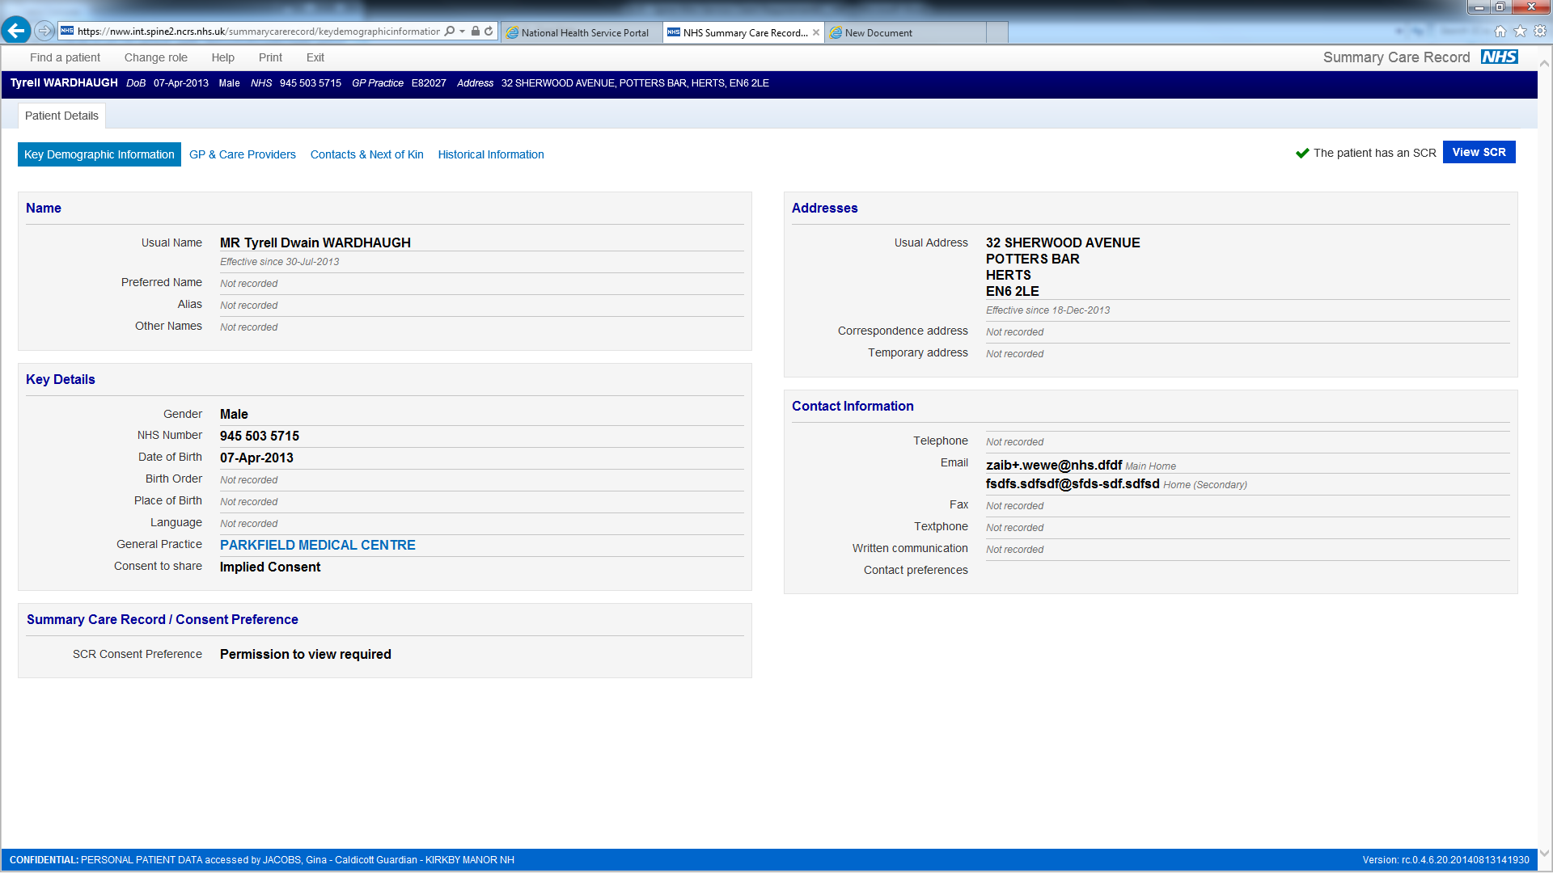
Indicating that a patient does not have an accessible SCR
This screen below illustrates how a system may indicate that a patient does not have an accessible SCR.
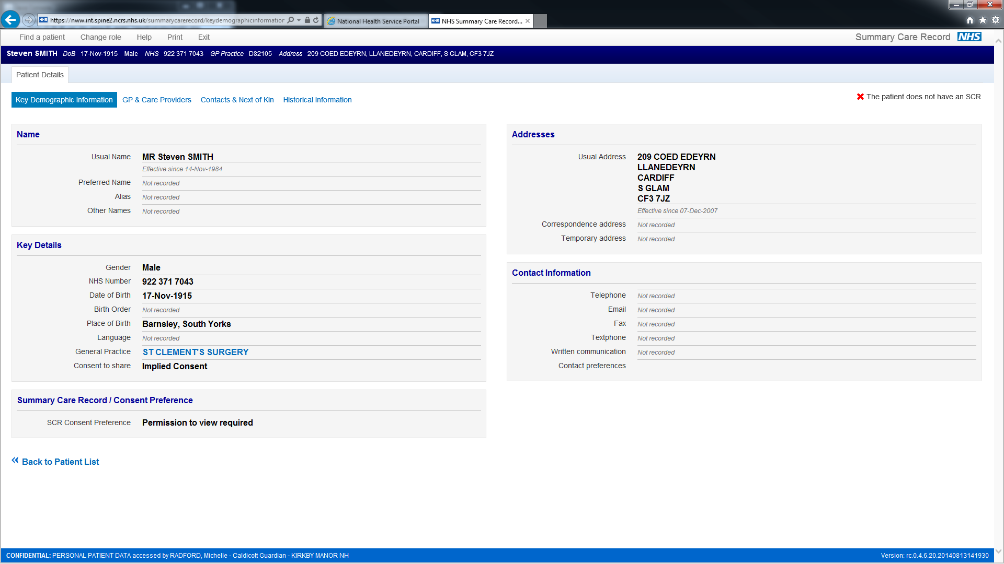

Obtaining Permission to View

The screens in this section illustrate how a Care Professional may be prompted to indicate if Permission to View has been obtained for themselves and \ or their colleagues, to access a patient’s SCR. The various combinations of options on the screens reflect the fact that a Care Professional’s RBAC Activities govern which options are available.

Screen 1
This screen below illustrates how a system may prompt a Care Professional to indicate if they are accessing a SCR:
- With the patient’s permission for themselves only.
- With the patient’s permission for themselves and other Care Professionals who may be involved in the patient’s care.
- For emergency reasons.
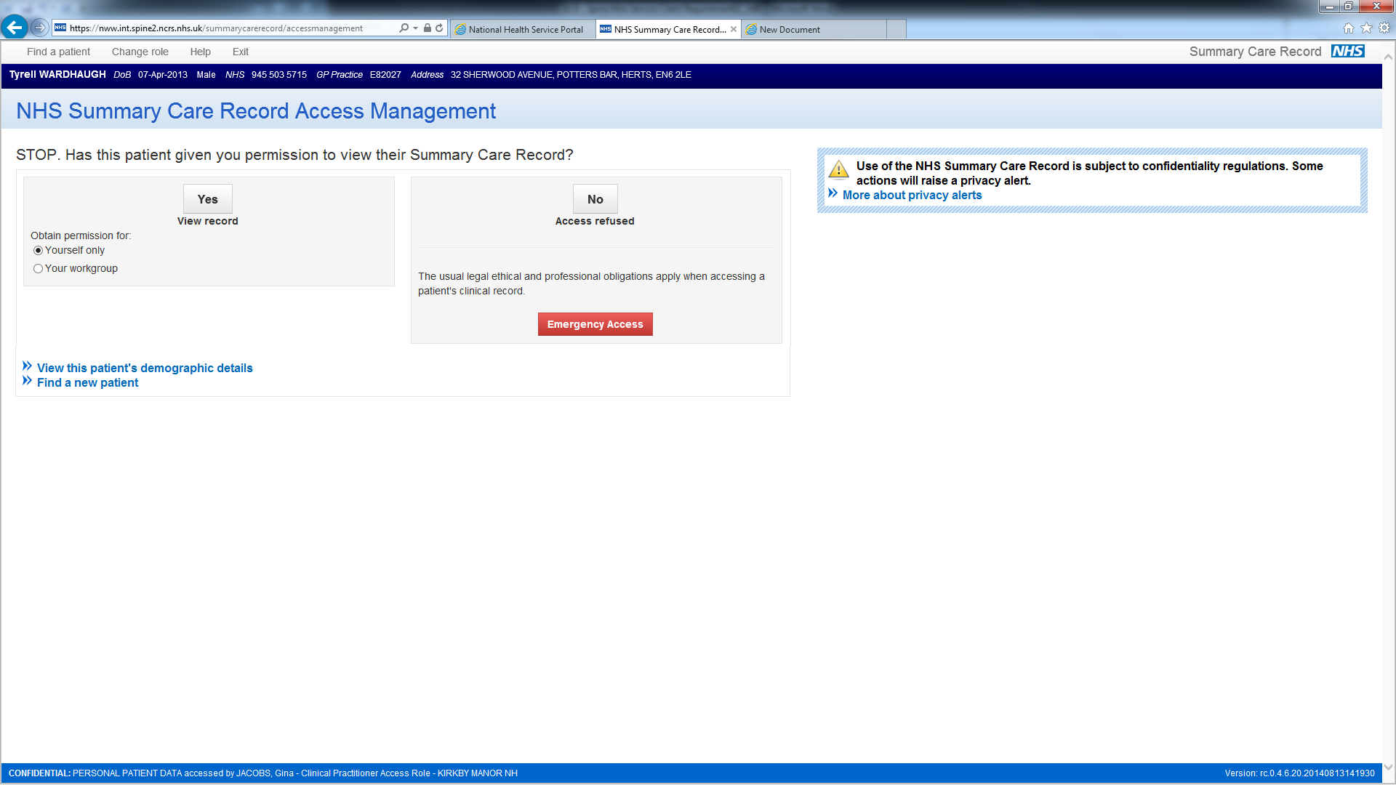
Screen 2

This screen below illustrates how a system may prompt a Care Professional to indicate if they are accessing a SCR:
- With the patient’s permission for themselves only
- For emergency reasons.
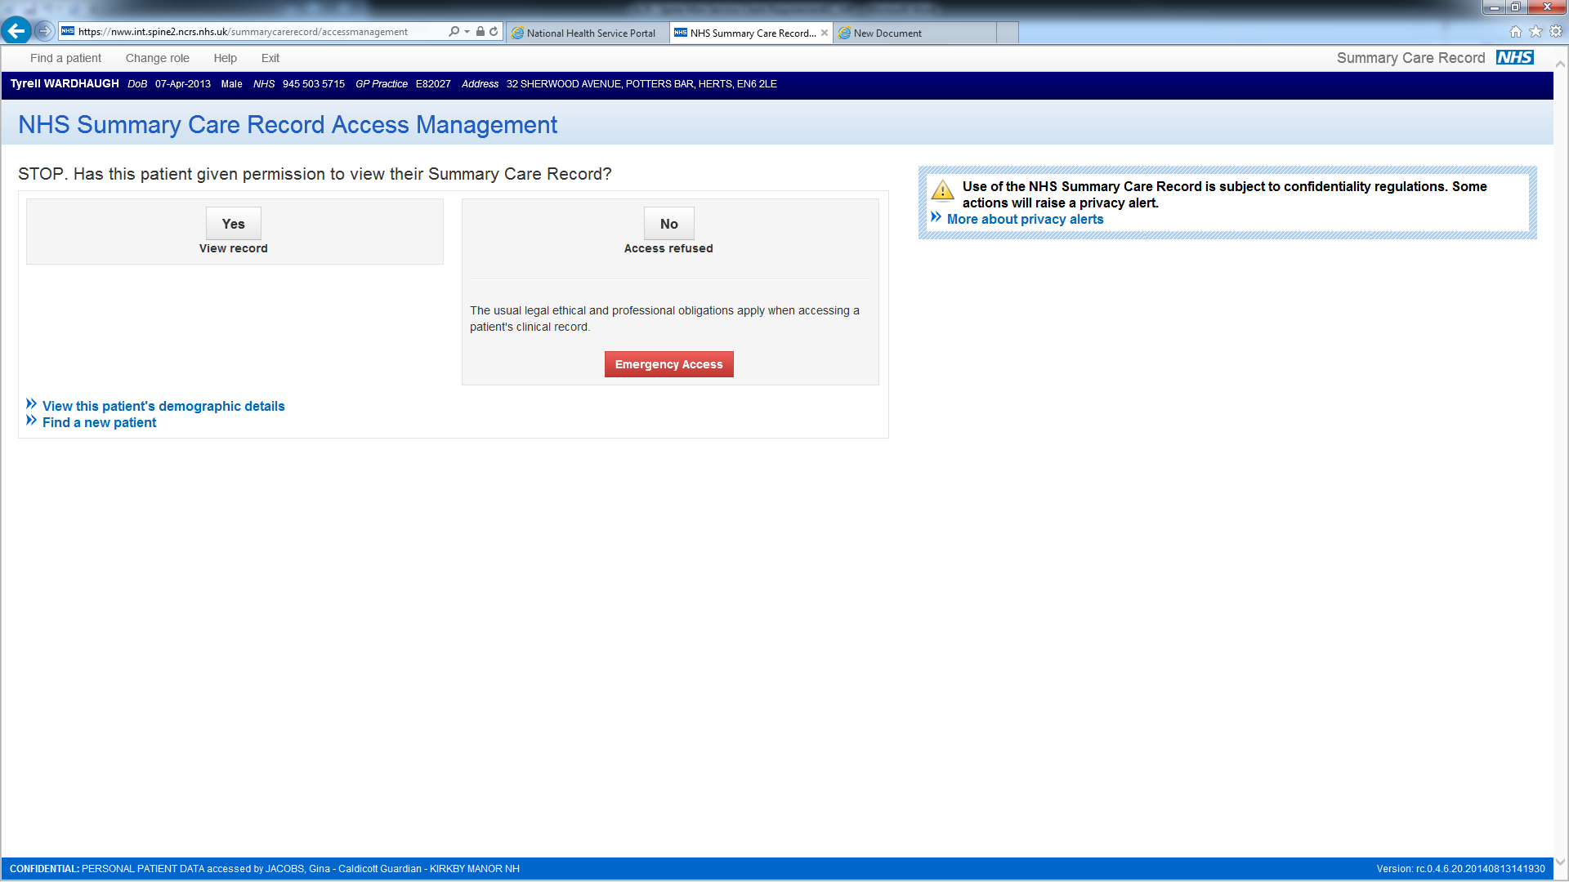

Screen 3
This screen illustrates how a system may prompt a Care Professional to indicate if they are accessing a SCR with the patient’s permission for themselves only:
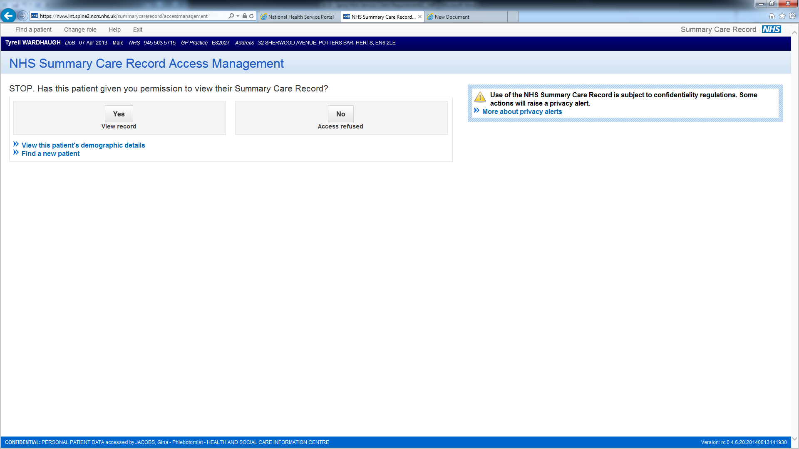
Accessing the SCR for Emergency Reasons
The screen below illustrates how a system may prompt a user to provide a reason for accessing a SCR in an emergency:
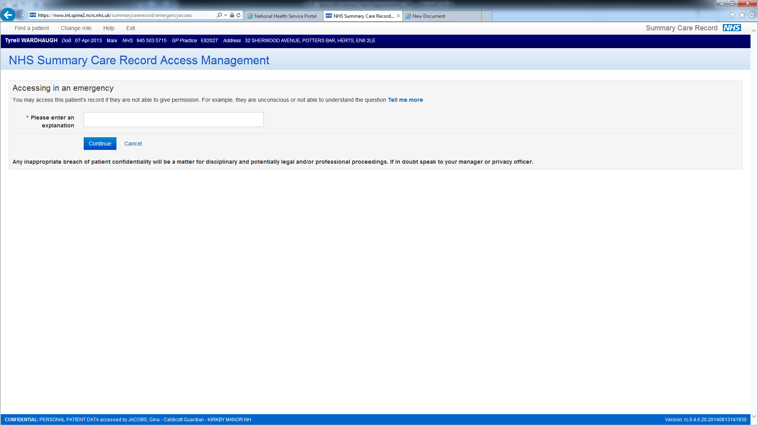

Administrative Support User creates Permission to View on behalf of Care Professionals

The screen below illustrates how a system may prompt an Administrative Support User to create Permission to View on behalf of one or more Care Professionals:

